# **TOPIC TO COVER:**

1. Database Design
2. CRUD, CRUD with AJAX, CRUD with API.
3. Database Design
4. One to One Relationship
5. One to Many Relationship
6. Many to Many Relationship
7. Contact Us & How to Send Mail.
8. Authentication and Middleware
9. Roles and Permission management using Saptie
10. Morph One and Morph Many
11. Laravel Module Package
12. Laravel Repository Design Pattern
13. Laravel Event and Listener
14. Pusher for Real Time Notifications
15. Livewire
16. Twilio
17. MailChimp
18. Laravel Package Development (Own Custom Package)
19. Use MongoDB(NoSQL) in Laravel
20. CronJob
21. Testing (Unit & Feature Testing)
22. Check User Status (Online or Offline)
23. Filters with AJAX
24. Download db table in excel, pdf and CSV File.
25. Import excel to db table.

# **Database Design:**

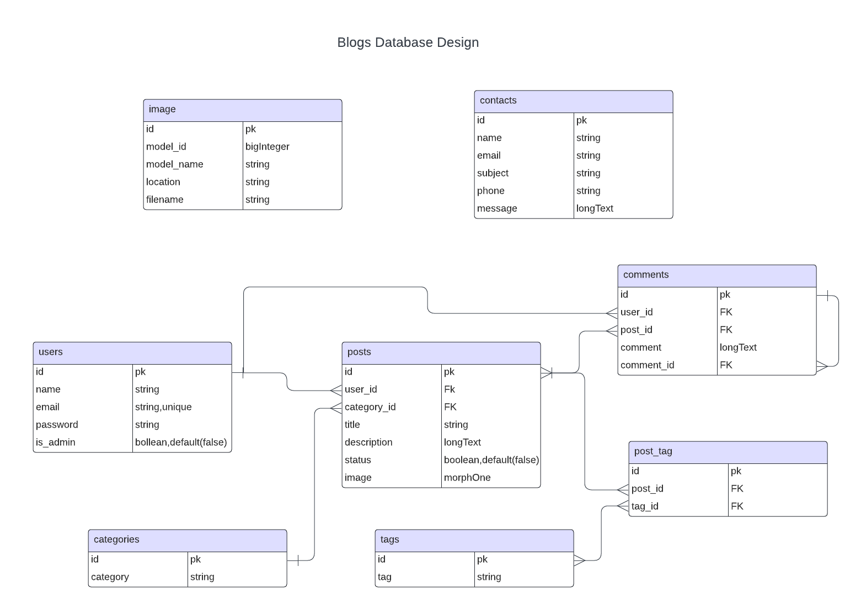

# 

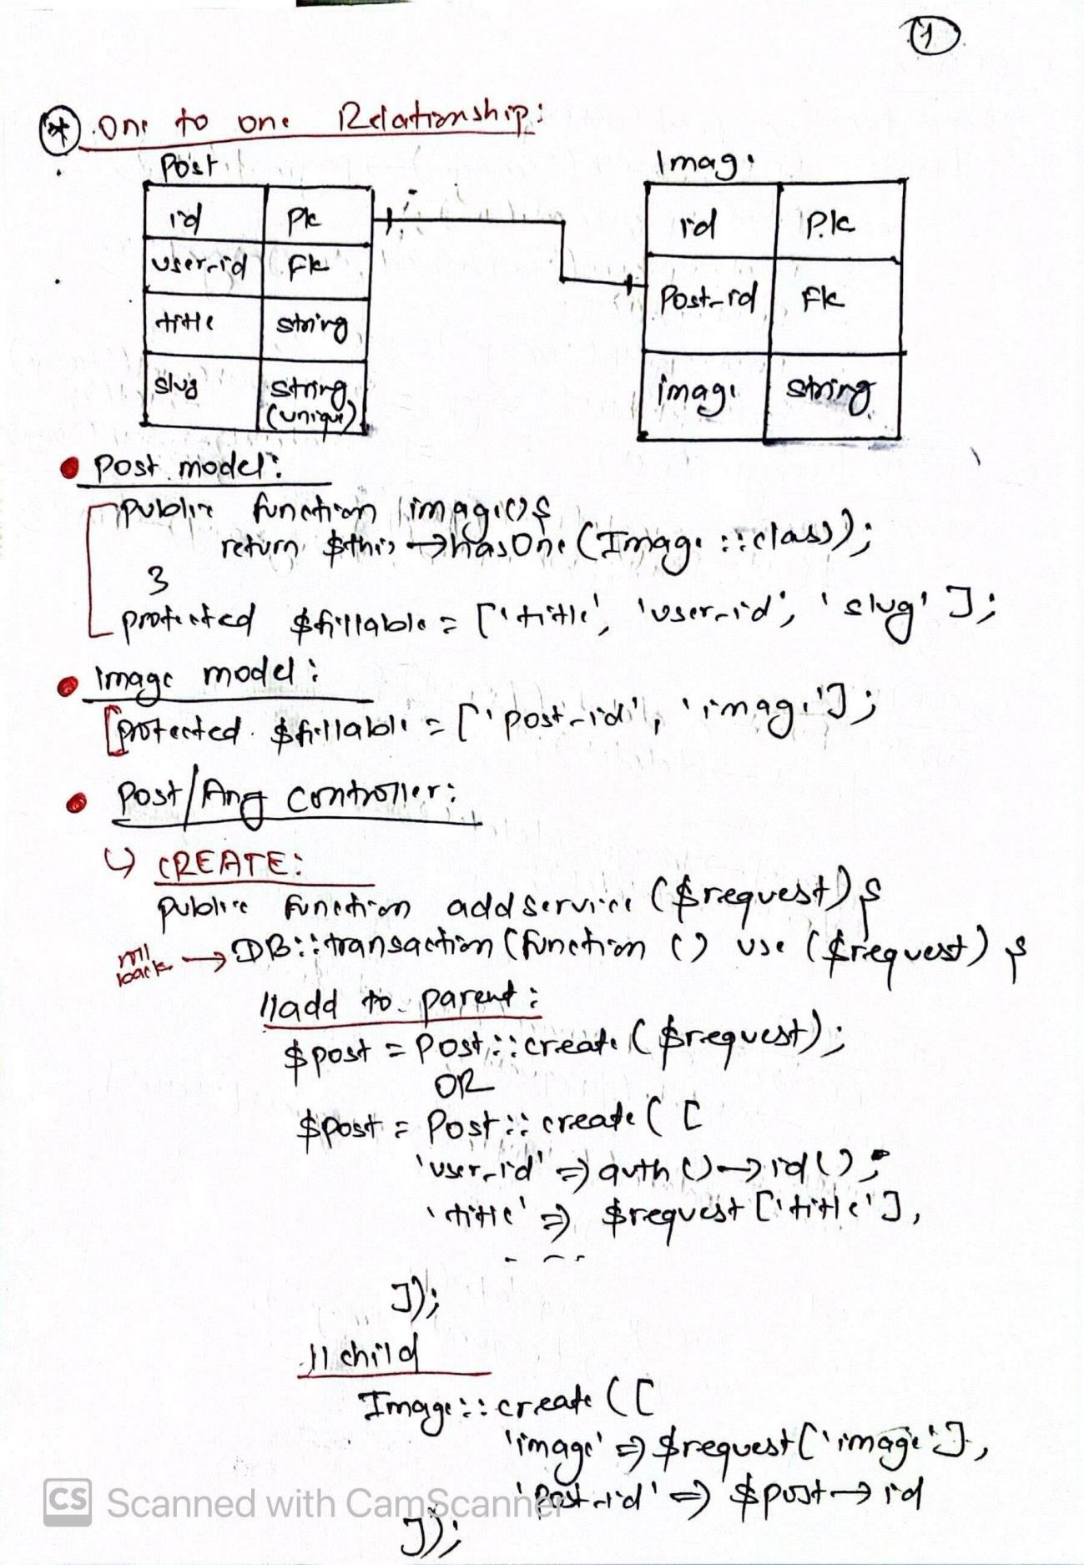

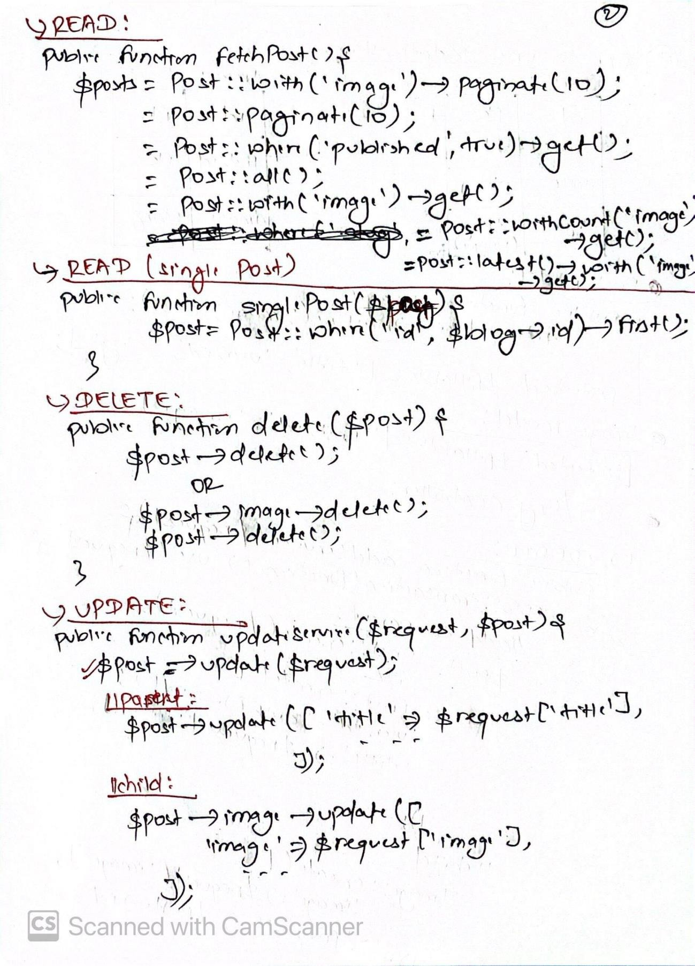

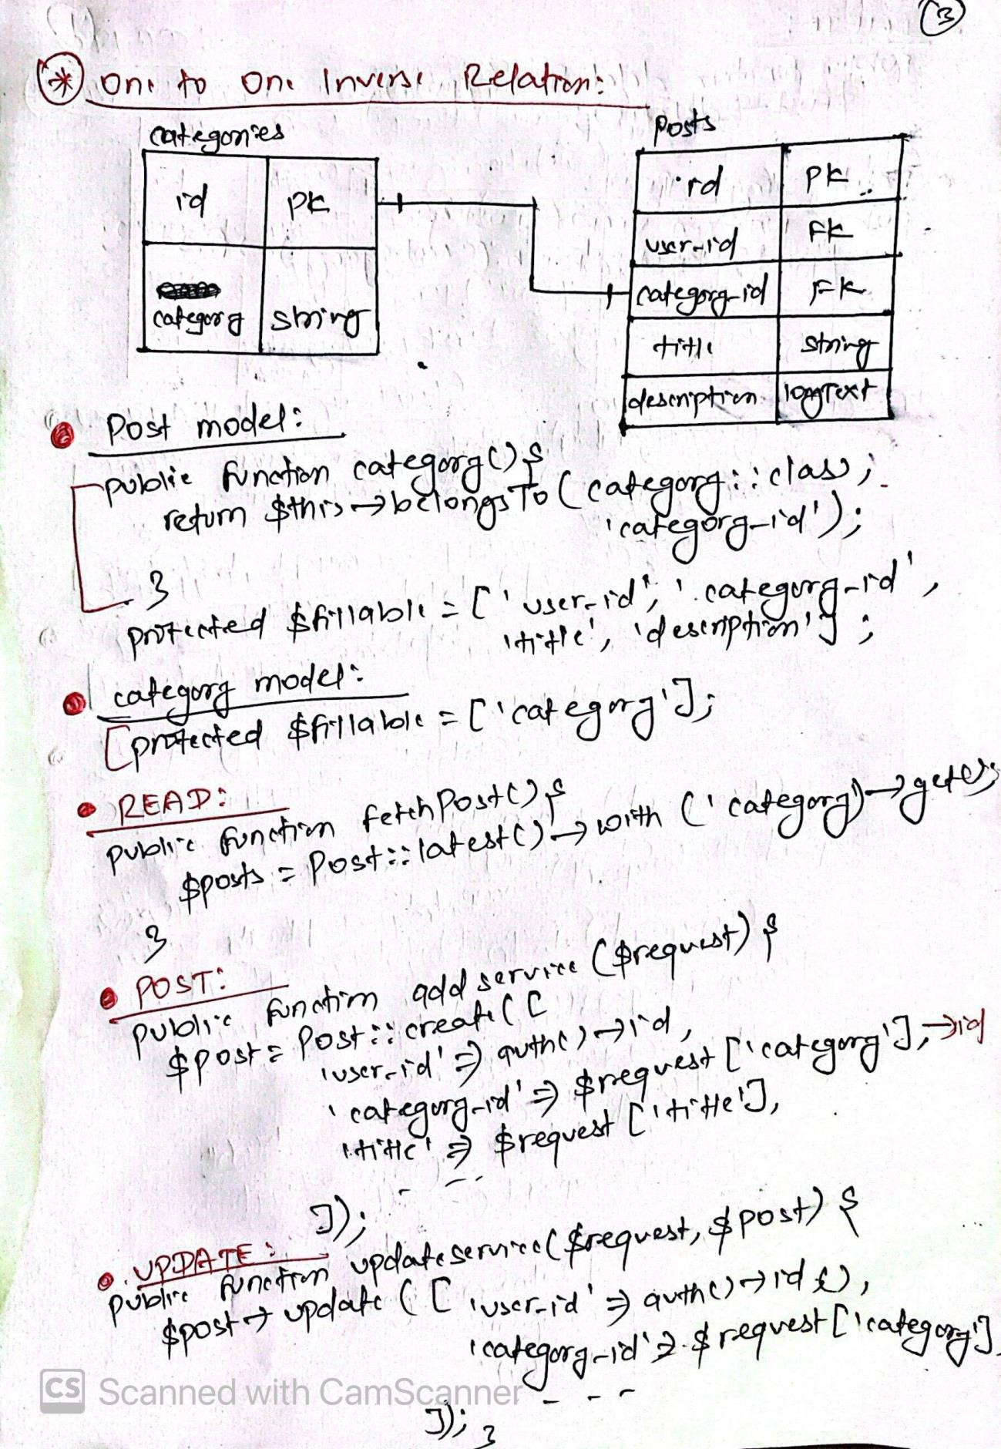

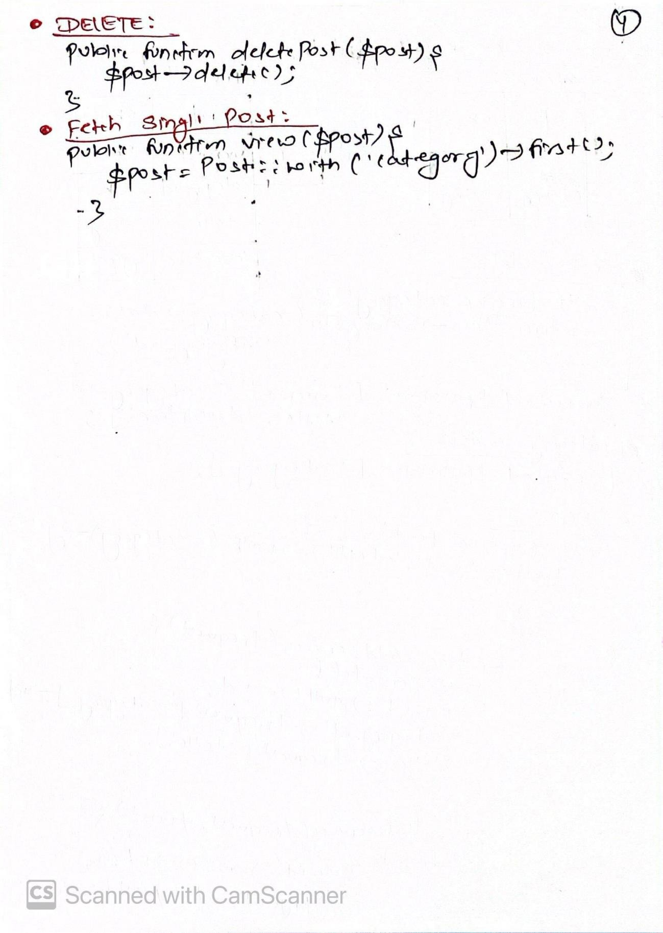

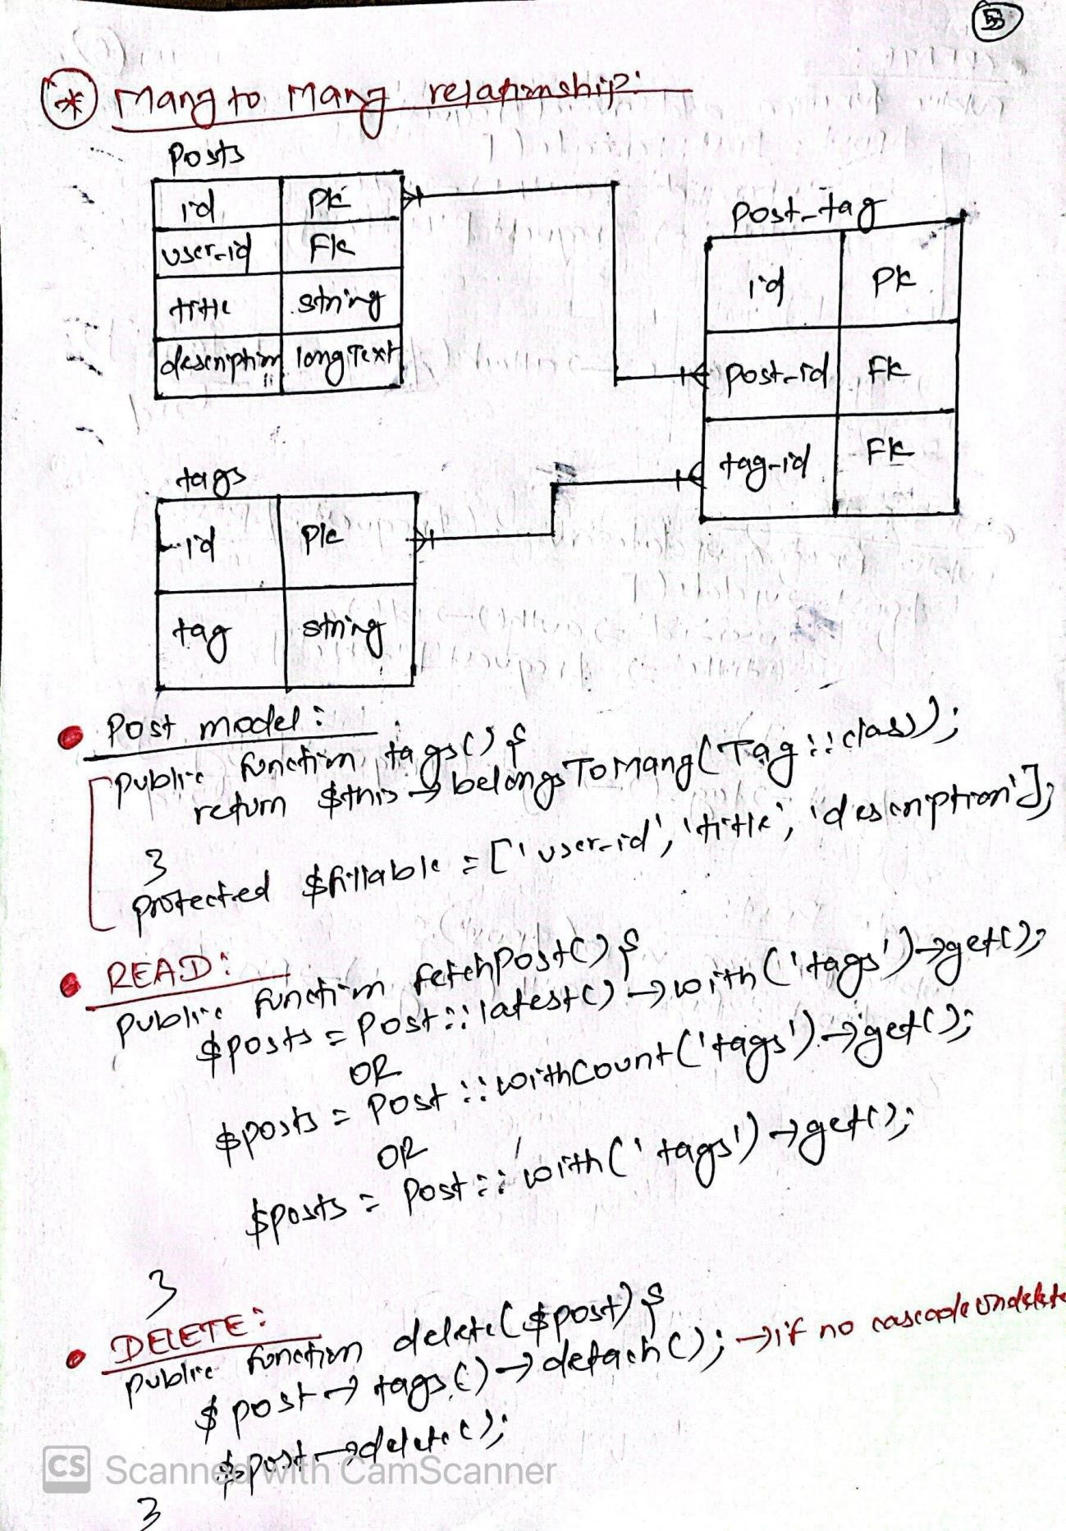

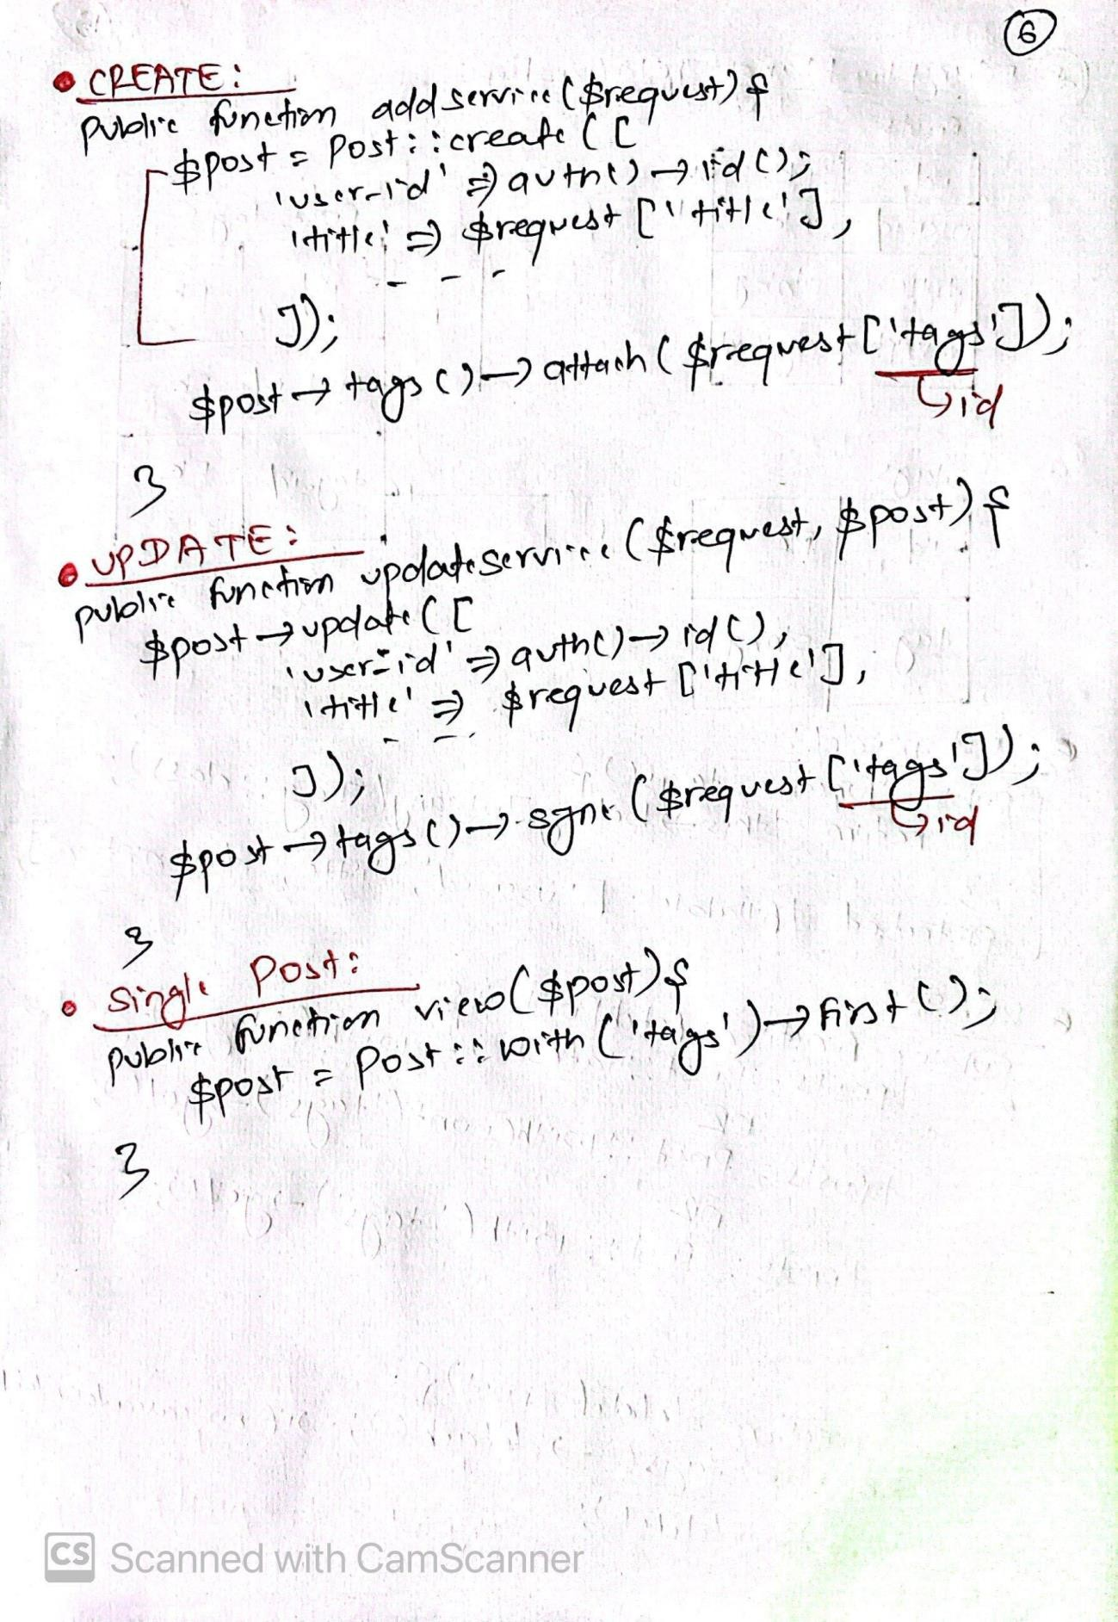

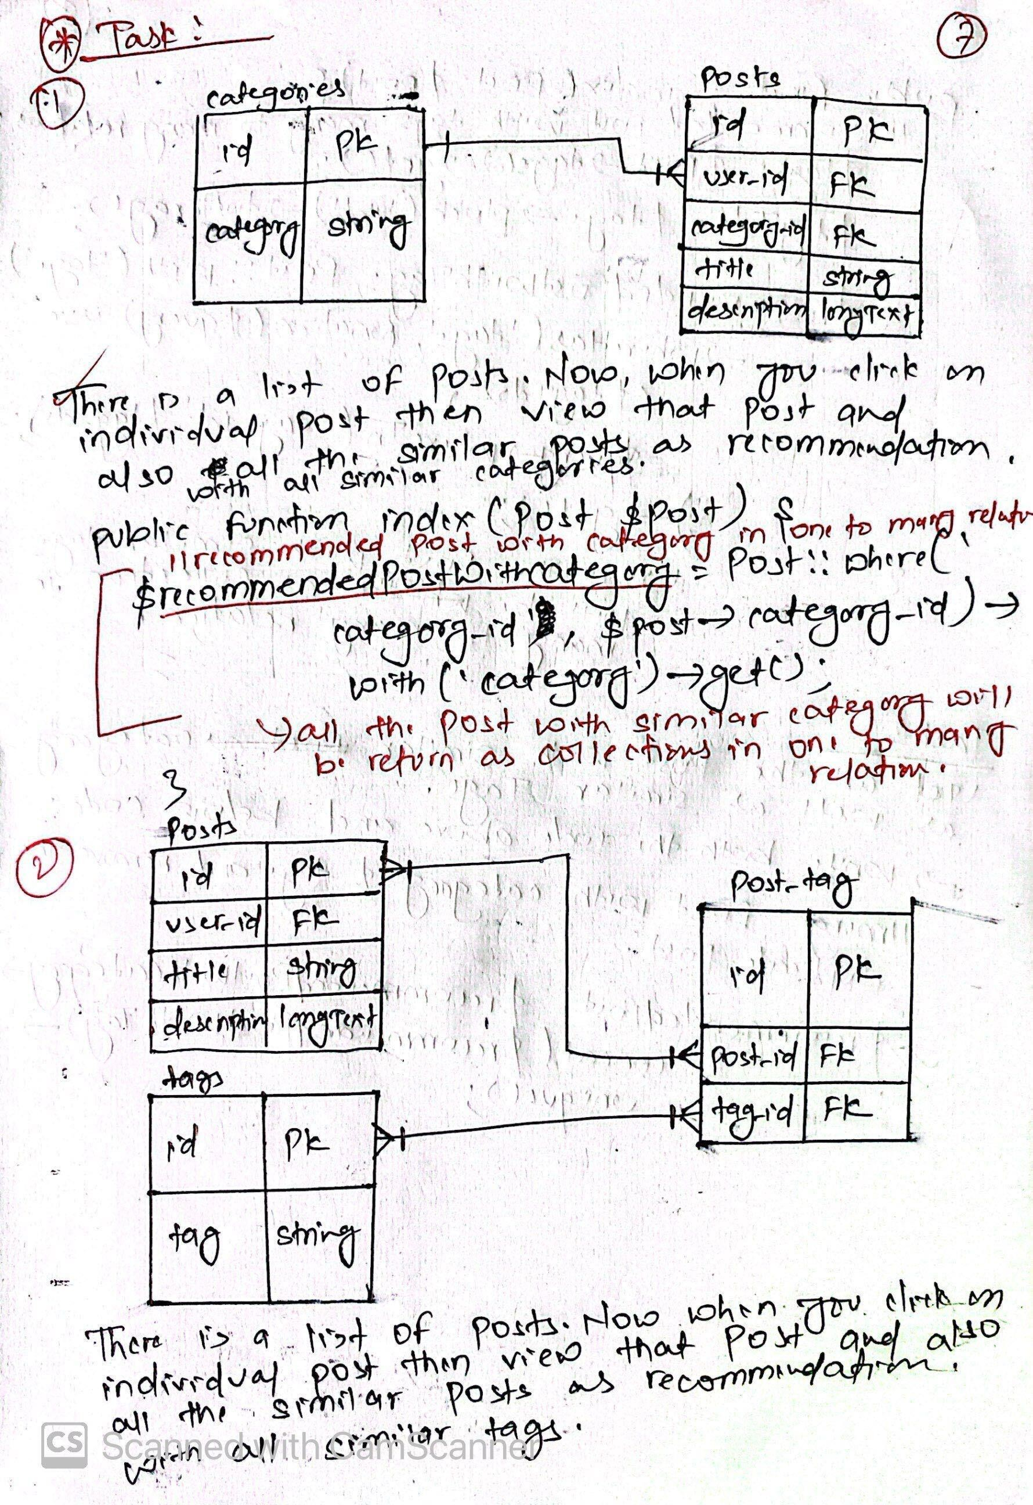

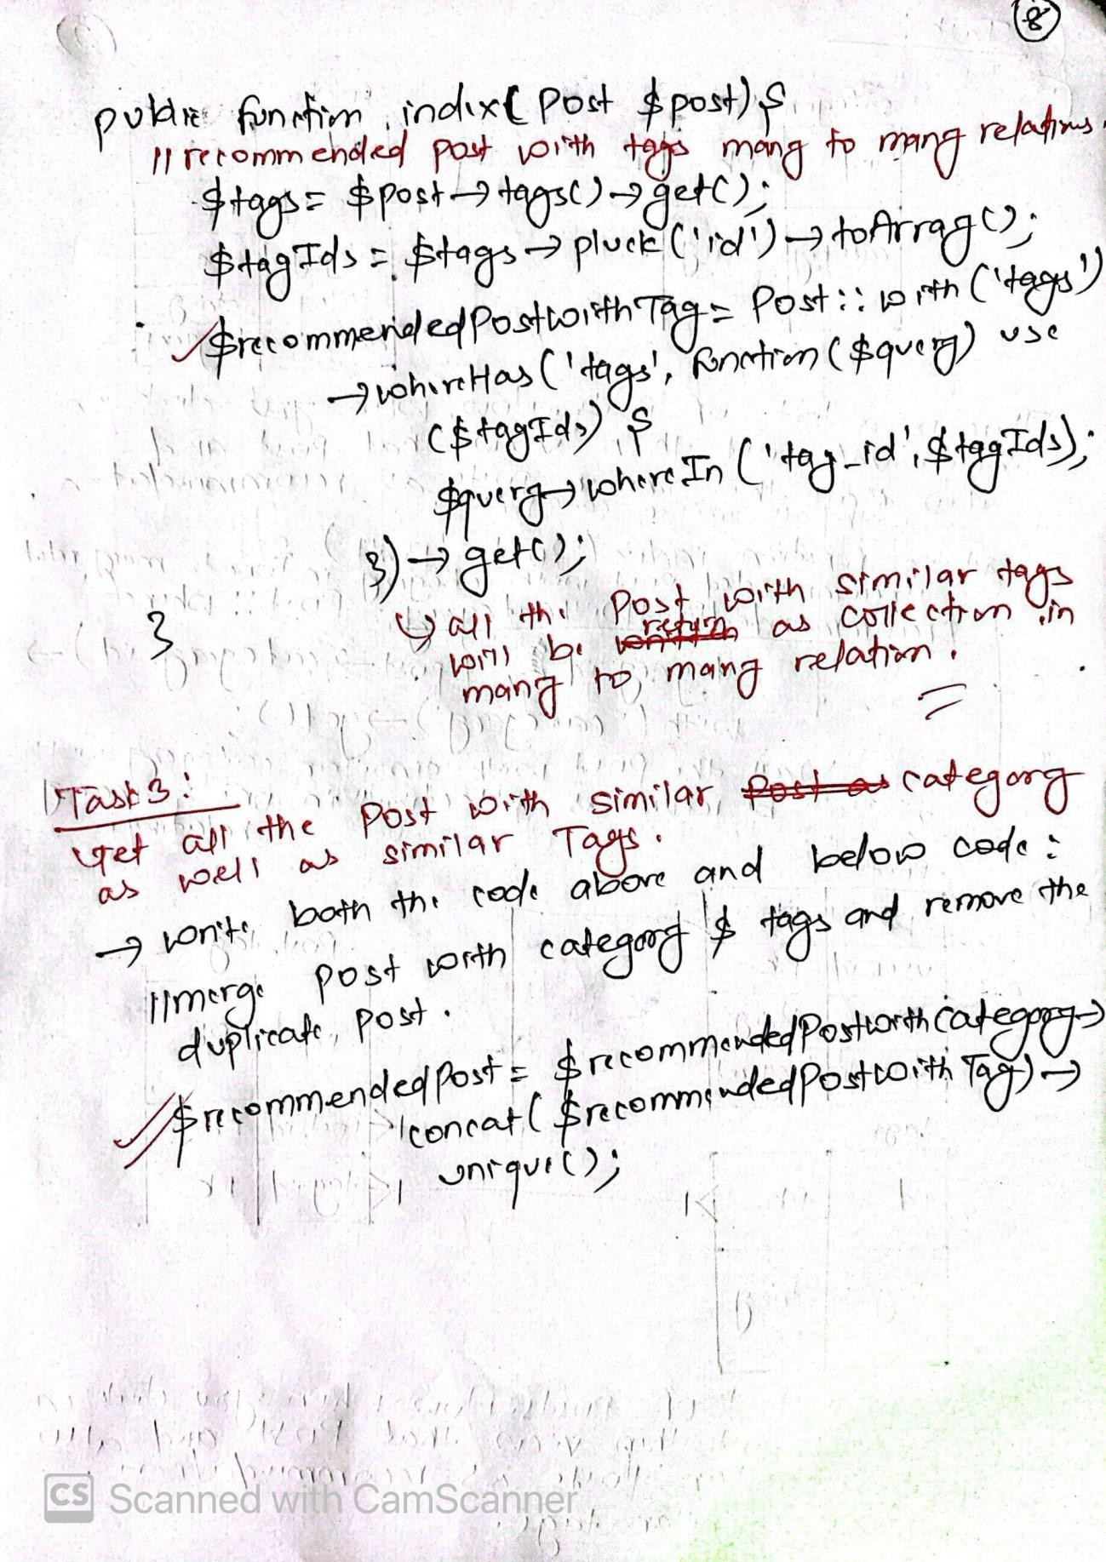

# Fetch all the data with Filter:

Example of One to One Relationship:

<?php

namespace App\Service; use App\Models\Blog;

use App\Models\BlogInfo;

use Illuminate\Support\Facades\Storage;

// one to one relation class BlogService

{

// =============POST============

public function addService($request)

{

// store single image in local storage folder if (isset($request['image'])) {

$timestamp = now()->timestamp;

$originalName = $request['image']->getClientOriginalName();

$imageName = $timestamp . '-' . $originalName;

$request['image']->storeAs('public/images/blogs', $imageName);

// update the image name in the $request array

$request['image'] = $imageName;

};

// store in database table

// Blog::create($request);

// =====one to one relation======

// store in parent table

$blog = Blog::create([

'title' => $request['title'], 'slug' => $request['slug'],

]);

// store in child table BlogInfo::create([

'image' => $request['image'], 'description' => $request['description'], 'blog_id' => $blog->id,

]);

}

// ========GET(Read all)================

public function fetchBlogs()

{

// $blogs=Blog::paginate(10); //Paginate with 10 records per page

// $blogs=Blog::where('published',true)->get(); //where published=true

// $blogs=Blog::select('SELECT * FROM blogs'); //raw sql

// $blogs=Blog::all(); //fetch all the records

$blogs = Blog::with('blog_info')->get(); //fetch all data with one to one relation

// $blogs=Blog::with('blog_info')->paginate(10); // fetch data relationship with one to one

return $blogs;

}

// =========DELETE==========

public function delete($blog)

{

// delete image from local storage

if (isset($blog->blog_info->image)) { Storage::delete('public/images/blogs/' . $blog->blog_info->image);

}

// if cascade on delete not used:

// $blog->blog_info->delete(); //delete child record

// $blog->delete(); //delete parent record

// if cascade on delete used:

$blog->delete();

}

// ========FETCH(Single Blog)====== public function singleBlog($blog)

{

// $blogs=Blog::where('slug',$blog->slug)->first(); return $blog;

}

// =======UPDATE(PUT)==============

public function updateService($request, $blog)

{

// $blog->update($request); //update data in db if no image & relation

// Check if a new image is uploaded if (isset($request['image'])) {

// Delete the old image from storage folder Storage::delete('public/images/blogs/' . $blog->blog_info->image);

// Store the new image

$timestamp = now()->timestamp;

$originalName = $request['image']->getClientOriginalName();

$imageName = $timestamp . '-' . $originalName;

$request['image']->storeAs('public/images/blogs', $imageName);

// Update the image name in the $request array

$request['image'] = $imageName;

} else {

$request['image'] = $blog->blog_info->image;

}

// Update in parent table

$blog->update([

'title' => $request['title'], 'slug' => $request['slug'],

]);

// Update in child table

$blog->blog_info->update([ 'image' => $request['image'],

'description' => $request['description'],

]);

}

}

# Example of One to Many Relationship:

<?php

namespace App\Service;

use App\Models\Blog;

use App\Models\BlogInfo;

use Illuminate\Support\Facades\Storage;

// one to many relation class BlogService

{

// =========POST======

public function addService($request)

{

// Initialize an empty array to store image names

$imageNames = [];

// Store multiple images in local storage folder if (isset($request['image'])) {

foreach ($request['image'] as $key => $image) {

$timestamp = now()->timestamp;

$originalName = $image->getClientOriginalName();

$imageName = $timestamp . '-' . $originalName;

$image->storeAs('public/images/blogs', $imageName);

// Store the image name in the array

$imageNames[] = $imageName;

}

}

// Create the Blog entry

$blog = Blog::create([

'title' => $request['title'], 'slug' => $request['slug'],

'description' => $request['description'],

]);

// Create BlogInfo entries associated with the Blog foreach ($imageNames as $imageName) {

BlogInfo::create([

'image' => $imageName, 'blog_id' => $blog->id,

]);

}

}

// ========GET(Read all)================

public function fetchBlogs()

{

// $blogs=Blog::paginate(10); //Paginate with 10 records per page

// $blogs=Blog::where('published',true)->get(); //where published=true

// $blogs=Blog::select('SELECT * FROM blogs'); //raw sql

// $blogs=Blog::all(); //fetch all the records

$blogs = Blog::with('blog_info')->get(); //fetch all data with one to one relation

// $blogs=Blog::with('blog_info')->paginate(10); // fetch data relationship with one to one

return $blogs;

}

// =========DELETE==========

public function delete($blog)

{

// delete image from local storage if (isset($blog->blog_info)) {

foreach ($blog->blog_info as $key => $image) { Storage::delete('public/images/blogs/' . $image->image);

}

}

// if cascade on delete not used:

// $blog->blog_info->delete(); //delete child record

// $blog->delete(); //delete parent record

// if cascade on delete used:

$blog->delete();

}

// ========FETCH(Single Blog)====== public function singleBlog($blog)

{

// $blogs=Blog::where('slug',$blog->slug)->first(); return $blog;

}

// =======UPDATE(PUT)==============

public function updateService($request, $blog)

{

// Check if new images are uploaded if (isset($request['image'])) {

// Delete old images from storage folder and database foreach ($blog->blog_info as $oldImage) {

// Delete from local storage Storage::delete('public/images/blogs/' . $oldImage->image);

// Delete from database

$oldImage->delete();

}

// Store the new images

foreach ($request['image'] as $key => $image) {

$timestamp = now()->timestamp;

$originalName = $image->getClientOriginalName();

$imageName = $timestamp . '-' . $originalName;

$image->storeAs('public/images/blogs', $imageName);

// Update in child table

$blog->blog_info()->create([ 'image' => $imageName,

]);

}

// Update in parent table

$blog->update([

'title' => $request['title'], 'slug' => $request['slug'],

'description' => $request['description'],

]);

} else {

// If no new images, update only the parent table

$blog->update([

'title' => $request['title'], 'slug' => $request['slug'],

'description' => $request['description'],

]);

}

}

}

# Many to Many Relationship:

// ===========POST(Add)=================

public function addService($request)

{

DB::transaction(function () use ($request) { //->roll back if not inserted in relationship table

// adding data in parent table

$post = Post::create([ 'user_id' => auth()->id(),

'caregory_id' => $request['category'], 'title' => $request['title'], 'description' => $request['description'], 'status' => $request['status'],

]);

});

}

// add data with many to many relation

$post->tags()->attach($request['tags']);

// =====================================

// ==============GET All==================

public function fetchPost()

{

$posts = Post::latest()->get(); return $posts;

}

// =======================================

// =========fetch single post=========== public function view($post)

{

$singlePost = Post::find($post->id); return $singlePost;

}

// =====================================

// ===========UPDATE POST==============

public function updateService($request, $post)

{

// updating data in parent table

$post->update([

'user_id' => auth()->id(), 'caregory_id' => $request['category'],

'title' => $request['title'], 'description' => $request['description'], 'status' => $request['status'],

]);

// updating data with many to many relation

$post->tags()->sync($request['tags']);

}

// ====================================

// =============DELETE=================

public function deletePost($post)

{

//if not used cascadeOnDelete() then you should detach from many to many relation else you can directly use delete only

$post->tags()->detach();

$post->delete();

}

// ====================================

# C:\Users\yubra\Downloads\image (2).pngC:\Users\yubra\Downloads\image (2).pngRouting:

CRUD With AJAX:

## Frontend(index.blade.php):

<script>

$(document).ready(function() {

// =====setup csrf token======

$.ajaxSetup({

headers: {

'X-CSRF-TOKEN': $('meta[name="csrf-token"]').attr('content')

}

});

// =====Reset form============

$('#addButton').click(function() {

$('#ajaxForm')[0].reset();

$('#categoryError').html('');

$('#slugError').html('');

});

// ========ADDING DATA TO DB(POST)=============//

var createFormData = $('#ajaxForm')[0];

$('#saveBtn').click(function() {

// setting empty text on error message

$('#categoryError').html('');

$('#slugError').html('');

// getting form data

var formData = new FormData(createFormData);

// console.log(formData);

$.ajax({

url: "{{ route('category.store') }}", method: 'POST',

processData: false, contentType: false, data: formData,

success: function(response) { table.draw();

$('#addCategory').modal('hide');

$('#ajaxForm')[0].reset(); toastify().success(response.success);

},

error: function(error) {

let errorMessage = error.responseJSON.errors; if (errorMessage) {

if (errorMessage.name) {

$('#categoryError').html(errorMessage.name[0]);

}

if (errorMessage.slug) {

$('#slugError').html(errorMessage.slug[0]);

}

} else {

toastify().error('Something went wrong');

}

});

}

});

// ======================================================//

// ===========READ DATA FROM DB(READ)====================//

var table = $('#category-table').DataTable({ "processing": true,

"serverSide": true, "deferRender": true, "ordering": false, searchDelay: 3000, "ajax": {

url: "{{ route('category.index') }}", type: 'GET',

dataType: 'JSON'

},

"columns": [{

data: 'DT_RowIndex', name: 'DT_RowIndex', searchable: false

},

{

data: 'name',

name: 'name',

},

{

data: 'slug', name: 'slug'

},

{

data: 'action', name: 'action', orderable: false,

searchable: false

},

],

"lengthMenu": [

[10, 20, 50, -1],

[10, 20, 50, "All"]

});

],

"pagingType": "simple_numbers"

// ====================================================//

// ================DELETE CATEGORY===================//

$('body').on('click', '.delButton', function() { let slug = $(this).data('slug');

if (confirm('Are you sure you want to delete it')) {

$.ajax({

url: '{{ url('admin/category/', '') }}' + '/' + slug, method: 'DELETE',

success: function(response) {

// refresh the table after delete table.draw();

// display the delete success message toastify().success(response.success);

},

error: function(error) { console.log(error);

}

});

}

});

// ==========================================//

// =====Fill Current Data to form while UPDATION========// let slug = '';

$('body').on('click', '.editButton', function() {

// get form slug

slug = $(this).data('slug');

$.ajax({

url: '{{ url('admin/category', '') }}' + '/' + slug +'/edit', method: 'GET',

success: function(response) {

$('#editCategory').modal('show');

$('#updateCategory').val(response.name);

$('#updateSlug').val(response.slug);

$('#category_slug').val(response.slug);

},

error: function(error) { console.log(error);

}

})

});

// =============================================================//

// =====UPDATING CATEGORY TO DB(UPDATE/PUT)===========//

var updateFormData = $('#ajaxFormUpdate')[0];

$('#updateBtn').click(function() {

// setting empty text on error message

$('#categoryUpdateError').html('');

$('#slugUpdateError').html('');

// getting form data

var formUpdateData = new FormData(updateFormData);

$.ajax({

url: '{{ url('admin/category/', '') }}' + '/' + slug, method: 'POST',

processData: false, contentType: false, data: formUpdateData,

success: function(response) {

// reload the latest row after added table.draw();

// hide model if success

$('#editCategory').modal('hide');

// clear form after successfully submitting

$('#ajaxFormUpdate')[0].reset();

// display success message if form submitted toastify().success(response.success);

},

[0]);

error: function(error) {

let errorMessage = error.responseJSON.errors;

// displaying error message if (errorMessage) {

if (errorMessage.title) {

$('#categoryUpdateError').html(errorMessage.title

}

if (errorMessage.slug) {

$('#slugUpdateError').html(errorMessage.slug[0]);

}

} else {

toastify().error('Something went wrong!');

}

}

});

});

//

======================================================================//

});

</script>

## CategoryController:

private $categoryService;

public function construct()

{

$this->categoryService = new CategoryService();

}

public function index(Request $request)

{

try {

if ($request->ajax()) {

$categories = $this->categoryService->fetchCategory(); return DataTables::of($categories)

->addIndexColumn()

->addColumn('action', function ($row) {

return '<a href="javascript:void(0)" class="btn btn-info editButton" data-slug="' . $row->slug . '">Edit</a>

<a href="javascript:void(0)" class="btn btn-danger delButton" data-slug="' . $row->slug . '">Delete</a>';

})

->rawColumns(['action'])

->make(true);

}

return view('admin.category.index');

} catch (\Throwable $th) {

return back()->with('error', $th->getMessage());

}

}

public function store(CategoryRequest $request)

{

try {

$this->categoryService->addService($request->validated()); return response()->json([

'success' => 'Category added successfully'

]);

} catch (\Throwable $th) {

return back()->with('error', $th->getMessage());

// return response()->json(['error' =>'Something went wrong'],500);

}

}

public function edit(string $slug)

{

try {

$category = $this->categoryService->fetchSingleCategory($slug); if (!$category) {

abort(404);

}

return $category;

} catch (\Throwable $th) {

return back()->with('error', $th->getMessage());

}

}

public function update(Request $request, string $slug)

{

try {

$category = Category::where('slug', $request->category_slug)-

>first();

if (!$category) { abort(404);

}

$this->categoryService->updateCategory($request->except('_method', 'category_slug'), $category);

return response()->json([

'success' => 'Category Updated Successfully'

], 201);

} catch (\Throwable $th) {

return back()->with('error', $th->getMessage());

}

}

public function destroy(string $slug)

{

try {

$category = Category::where('slug', $slug)->first(); if (!$category) {

abort(404);

}

$this->categoryService->delete($category); return response()->json([

'success' => 'Category Deleted Successfully'

], 201);

} catch (\Throwable $th) {

return back()->with('error', $th->getMessage());

}

}

Search Blogs without page load using AJAX:

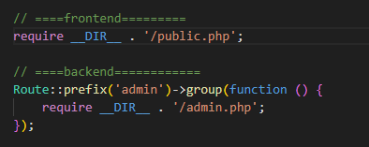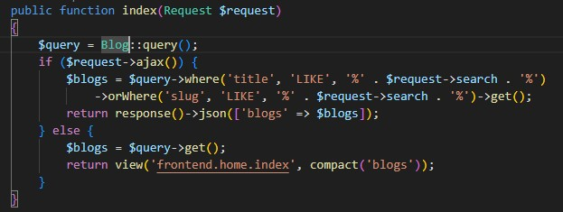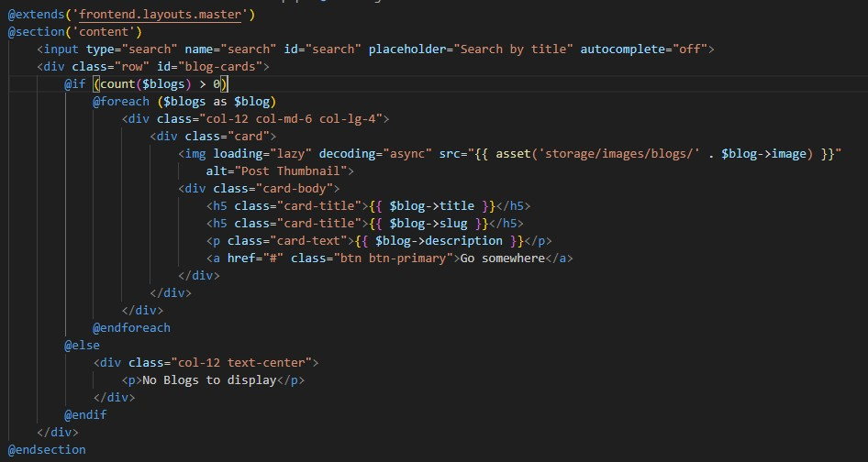

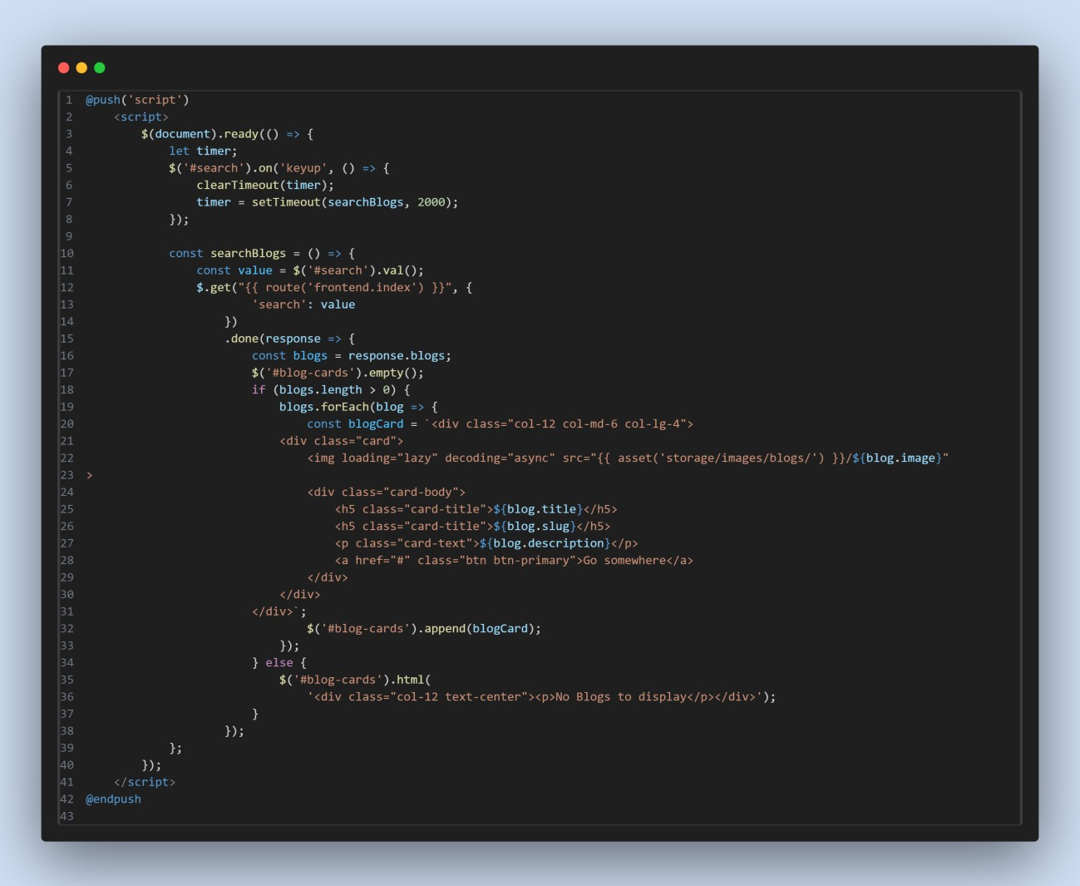

# **Contact Us & Send Mail in Laravel:**

1. index.blade.php

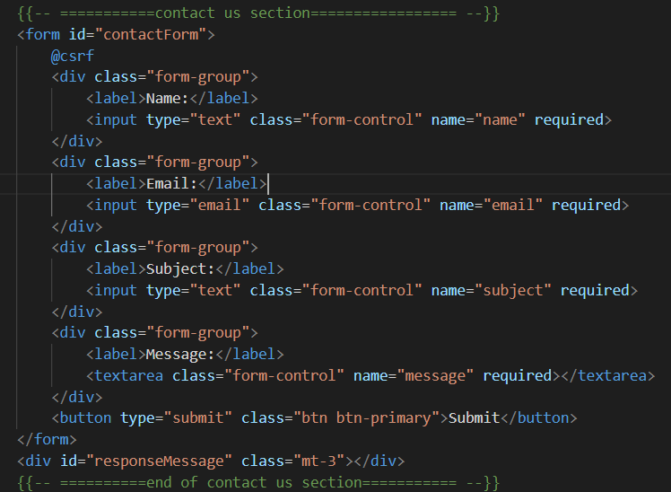

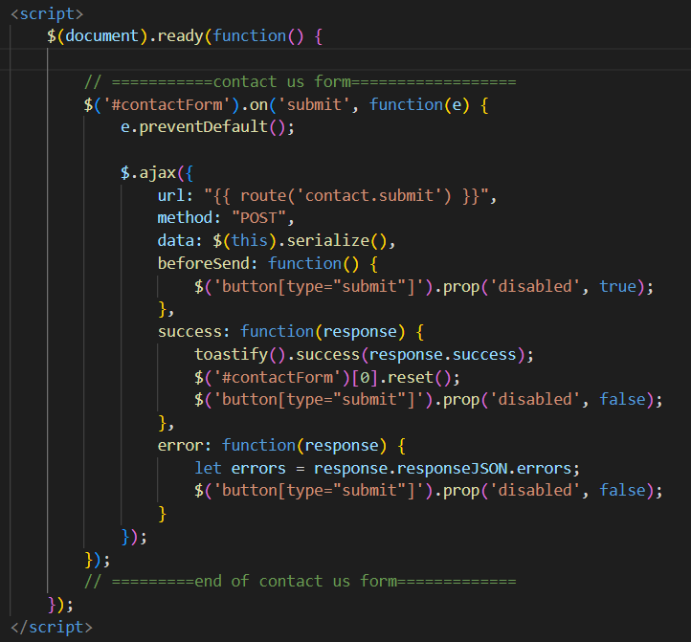

1. In web.php



1. In HomeController.php

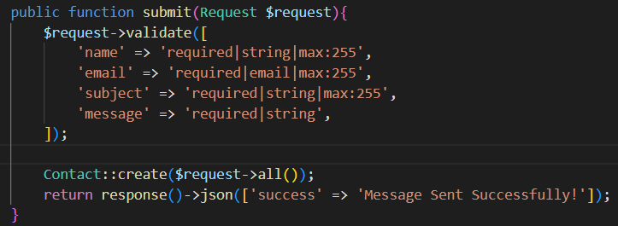

1. This will only save user contact information into db..so now we will create an event & Listener to send email that notify all the admin’s that someone want to contact with us.
2. Make Event:

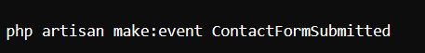

1. Inside your controller:

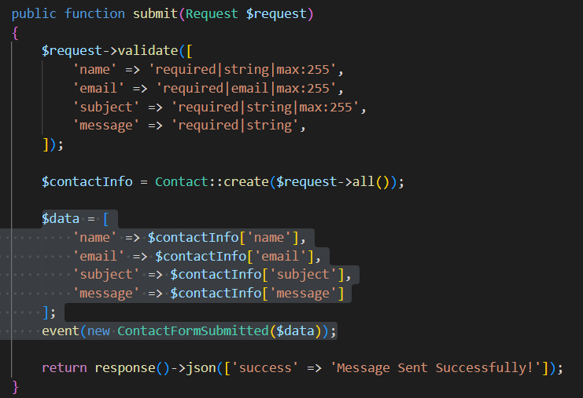

1. Inside your event ContactFormSubmitted.php

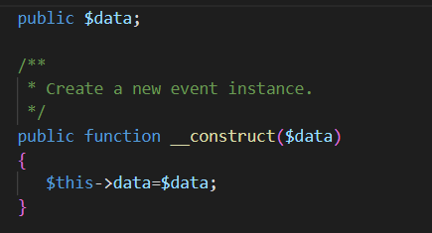

1. Make listener to listen your event(ContactFormSubmitted.php)



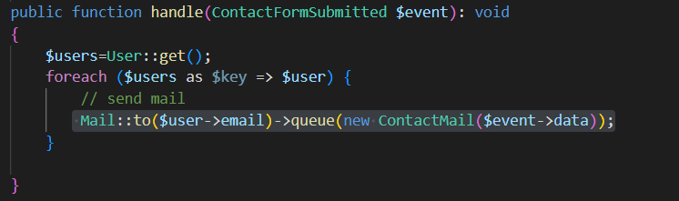

1. Inside EventServiceProvider.php

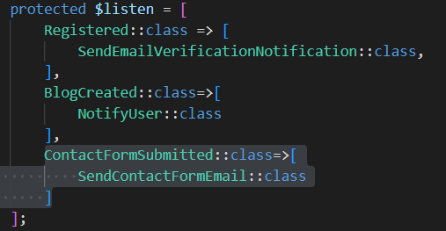

1. Make mail to send mail:

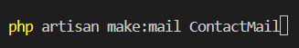

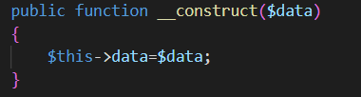

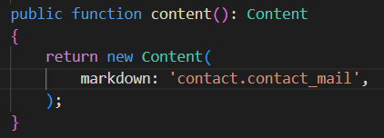

1. Inside views/contact/contact_mail.blade.php

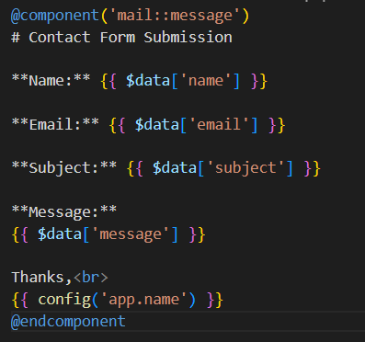

1. Inside .env

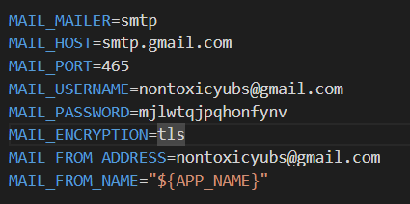

**Get password from security->2-step verification->Next->App Passwords**

1. Queues allow you to defer time-consuming tasks, such as sending emails or

generating reports, to be processed in the background, freeing up your

application to handle other requests.

1. **php artisan queue:table**
2. **in .env**



1. **Inside ContactMail.php**



1. **php artisan migrate**
2. **php artisan queue:listen**

# **Authentication using Laravel UI Package:**

## 

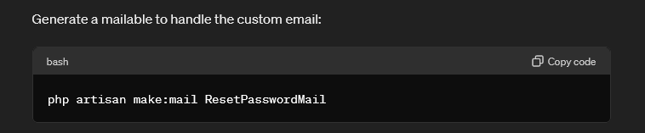



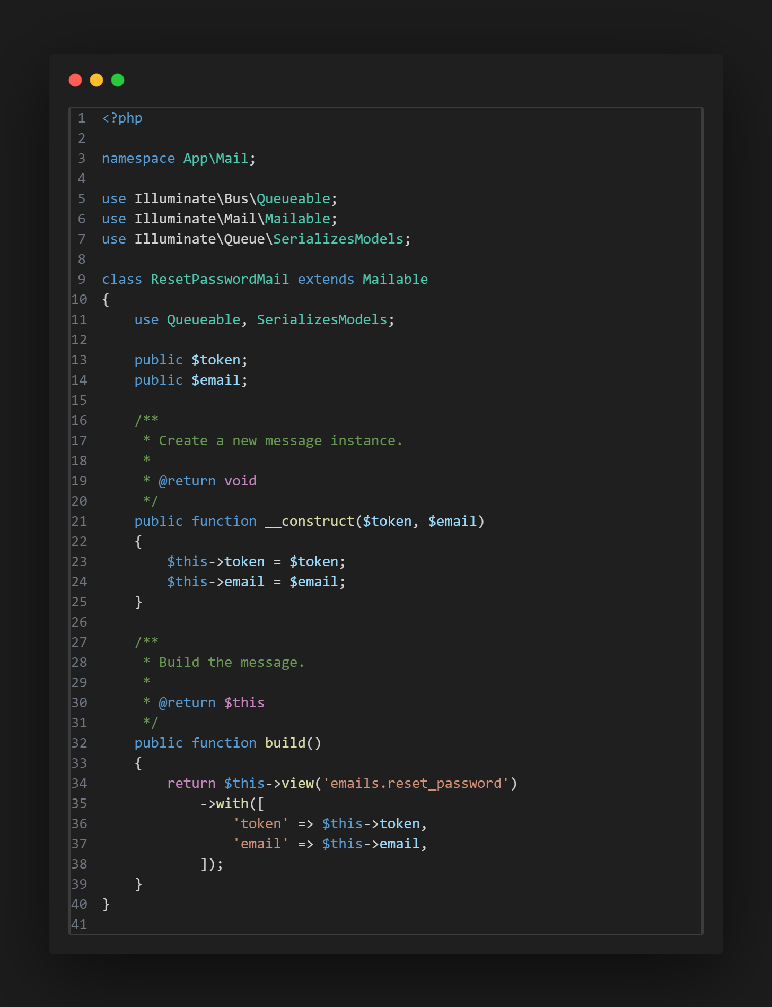

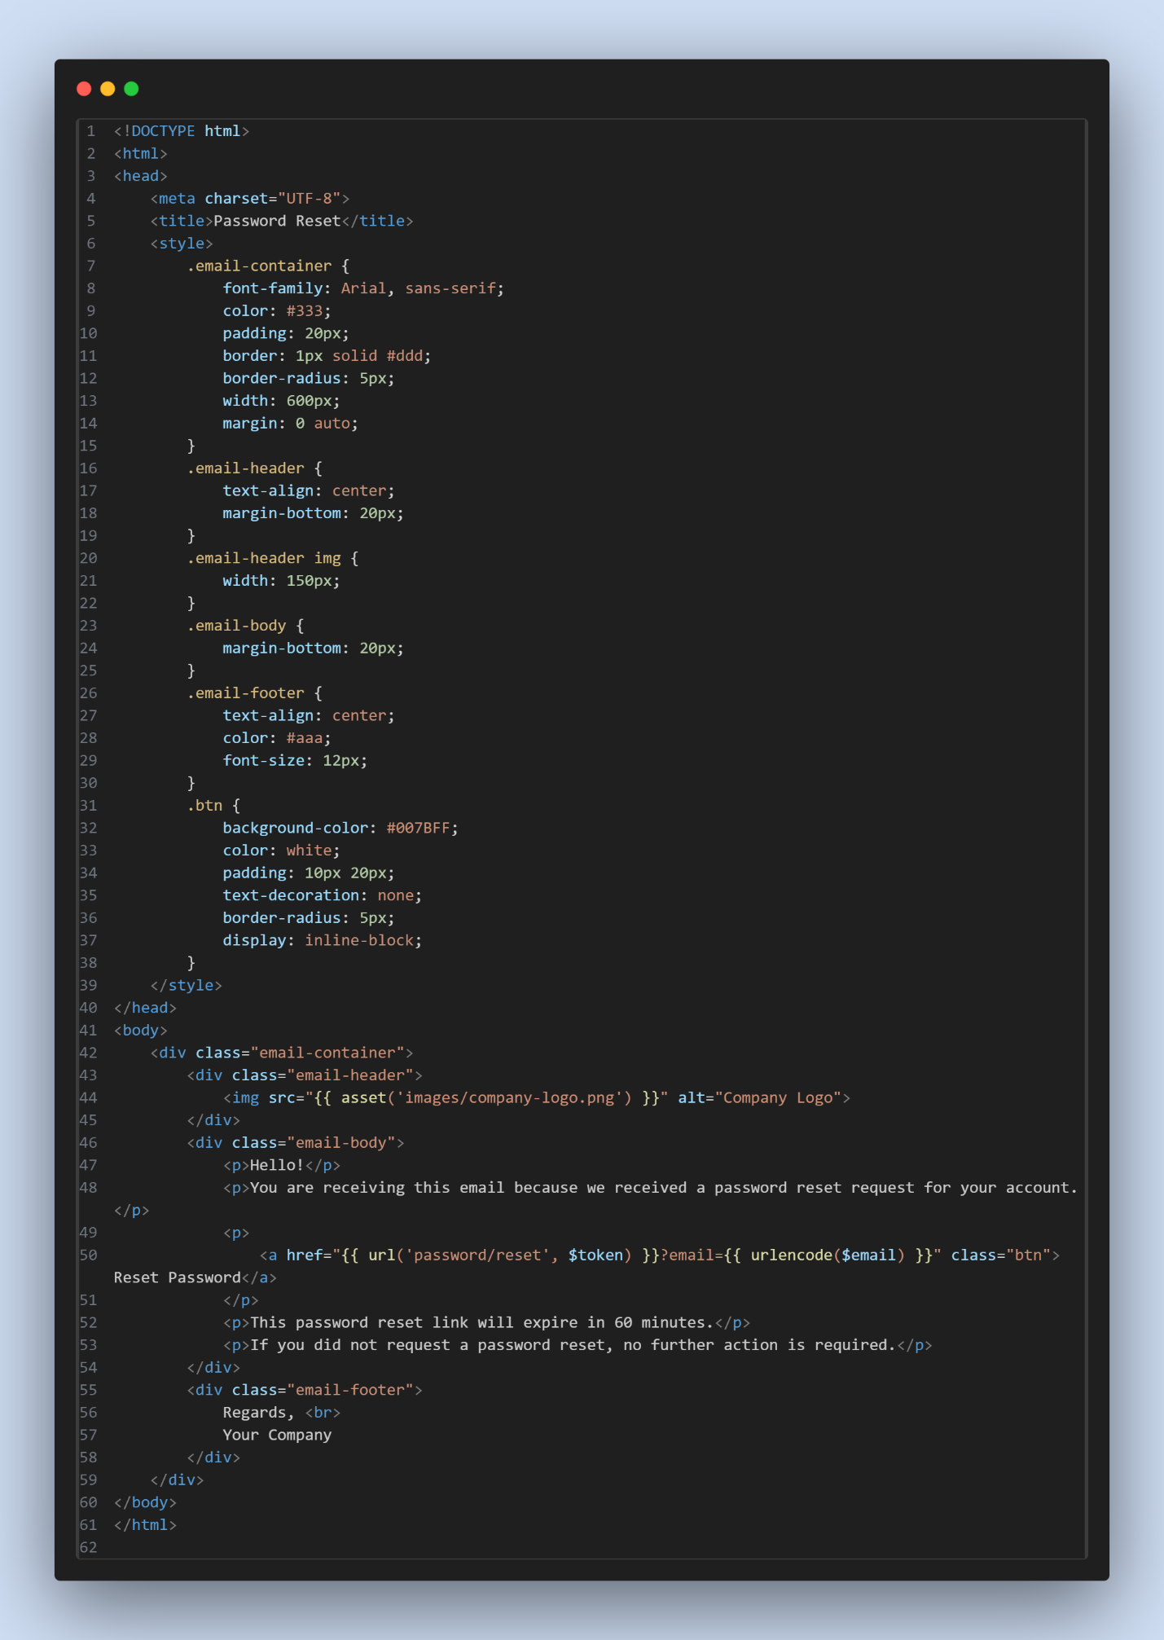

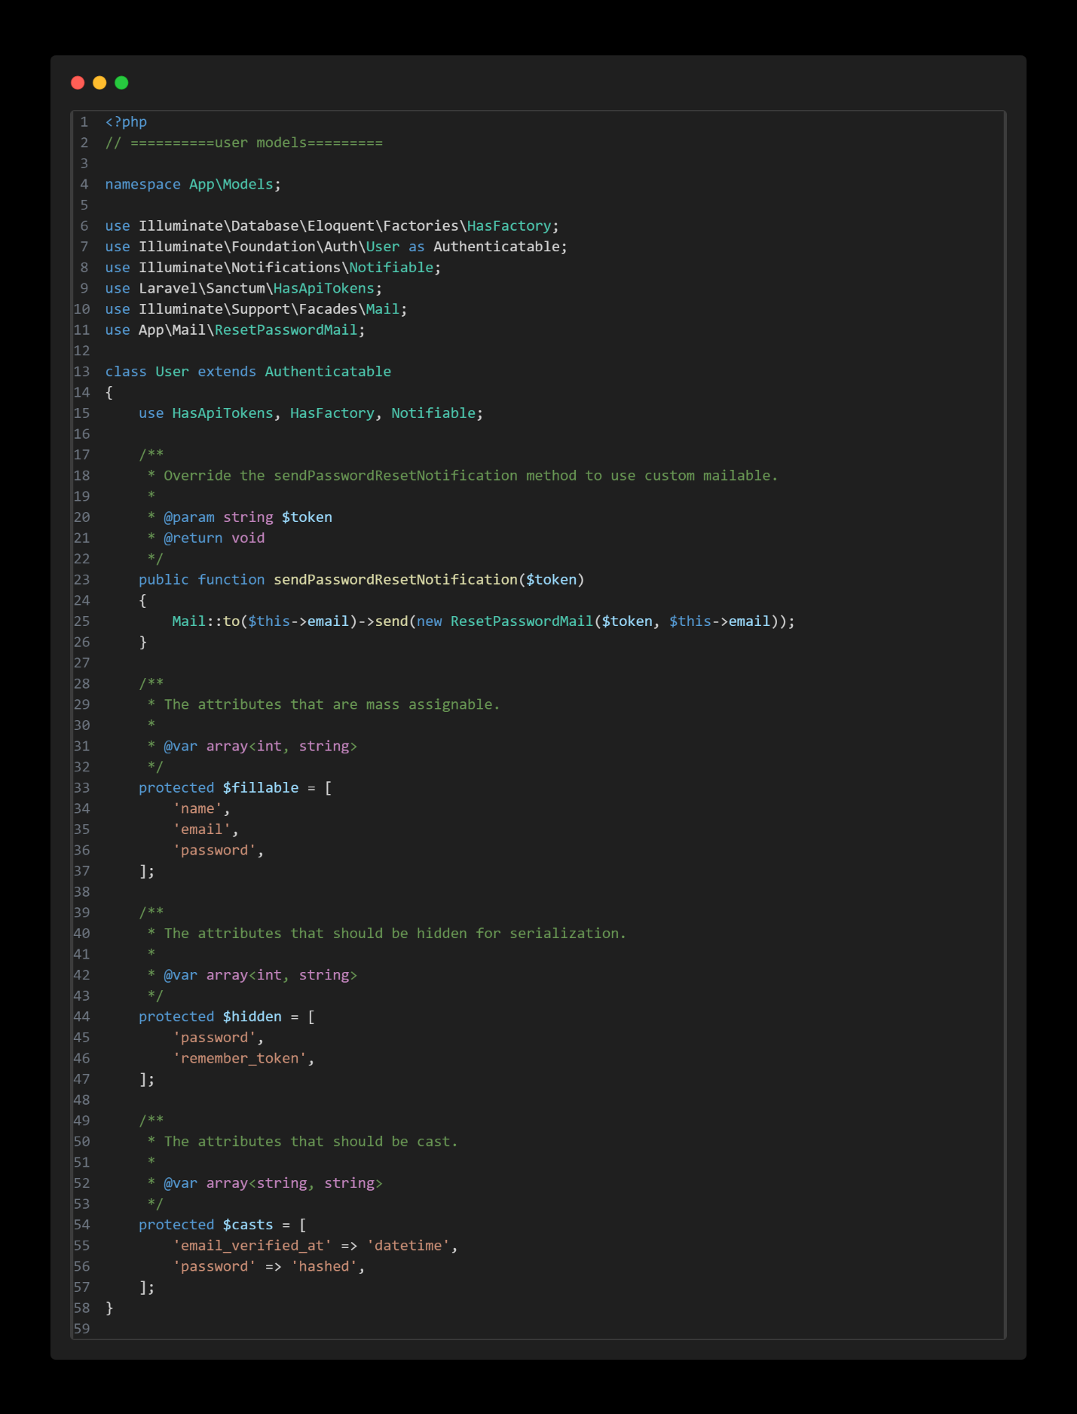

## **Email verification:**

Step 1: (web.php)

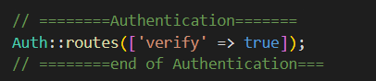

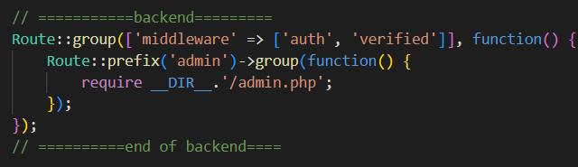

Step 2: (VerificationController.php)

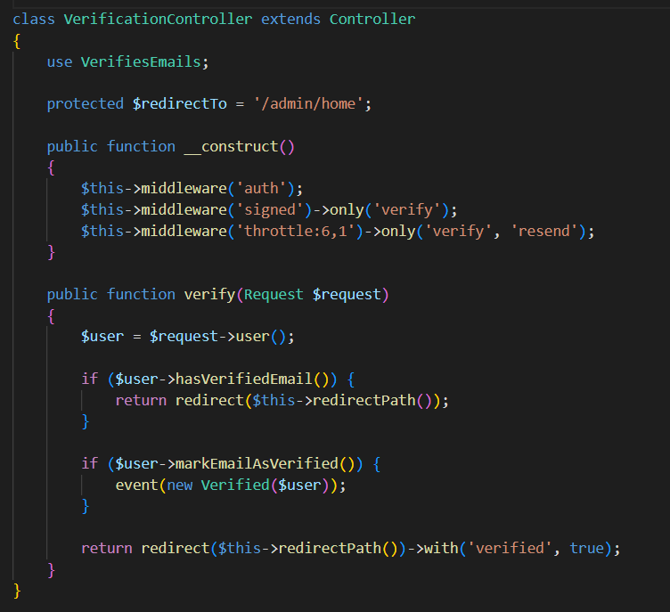

Step 3: (User modal)



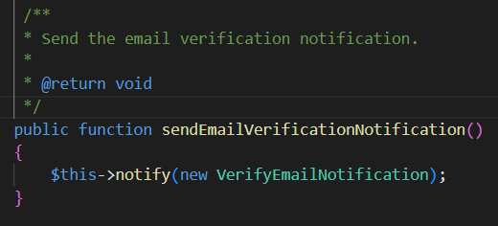

Step 4: (VerifyEmailNotification.php)

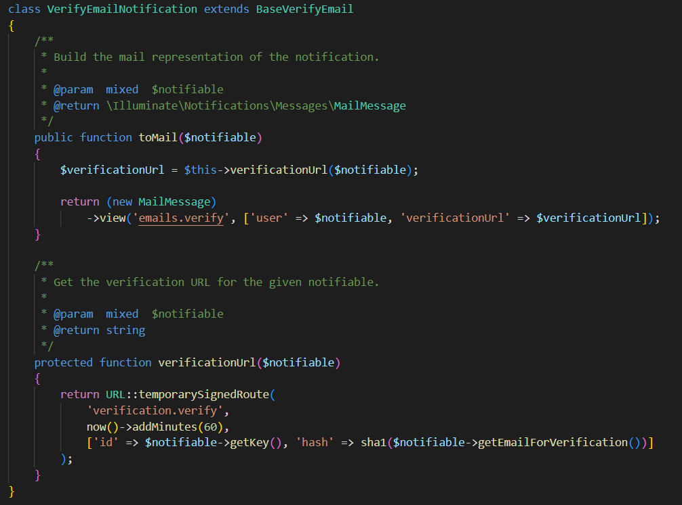

Step 5: (resources/views/emails/verify.blade.php)

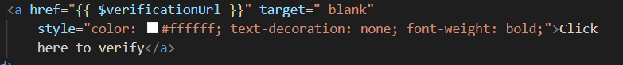

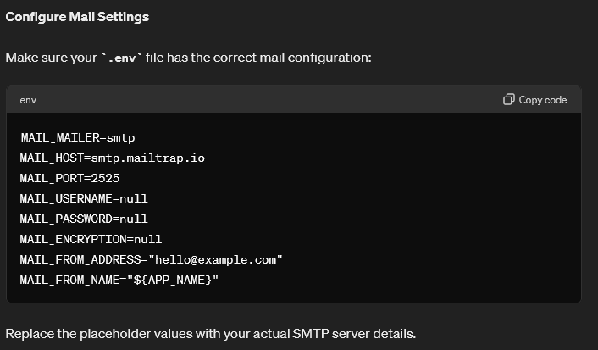

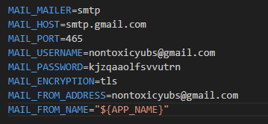

Get password from security<2-step-verification<App Passwords

# **Middleware:**

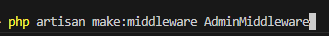

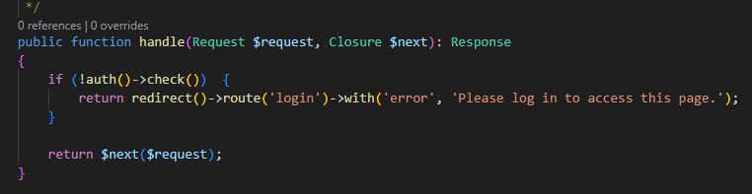

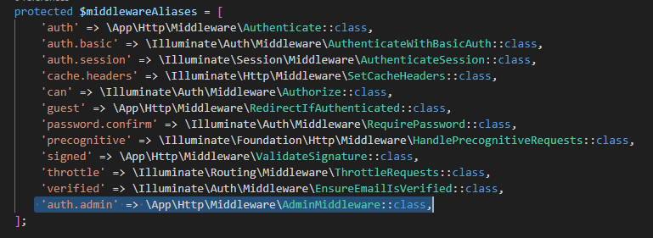

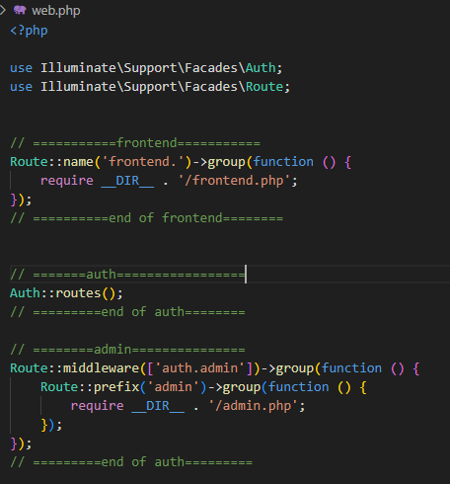

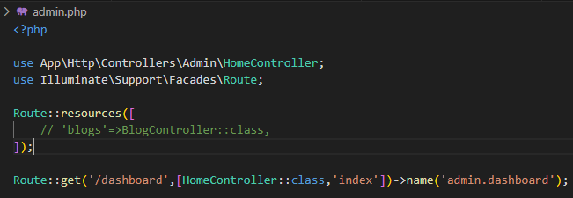

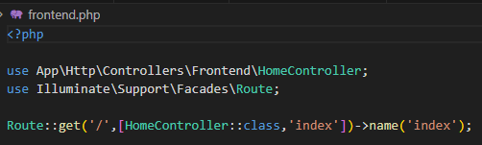

<https://amanj0314.medium.com/how-to-use-laravel-middleware-to-protect-your-application-1c76aa0acded>

# **Spatie user Roles & Permission management:**

<https://spatie.be/docs/laravel-permission/v6/installation-laravel>

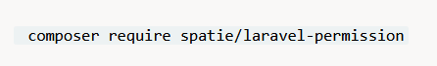

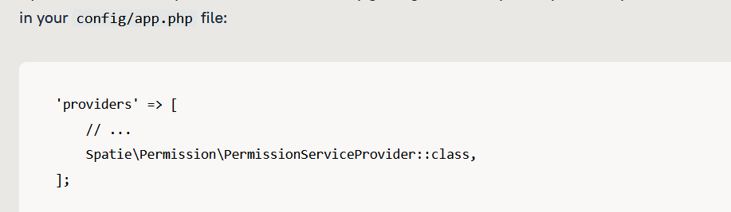

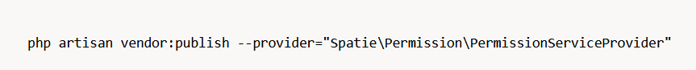

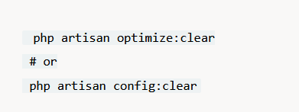

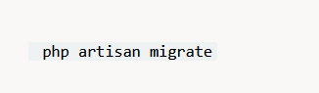

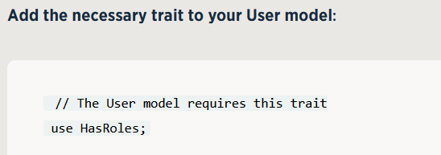

**Make Permission and Role Controller and do crud operation:**

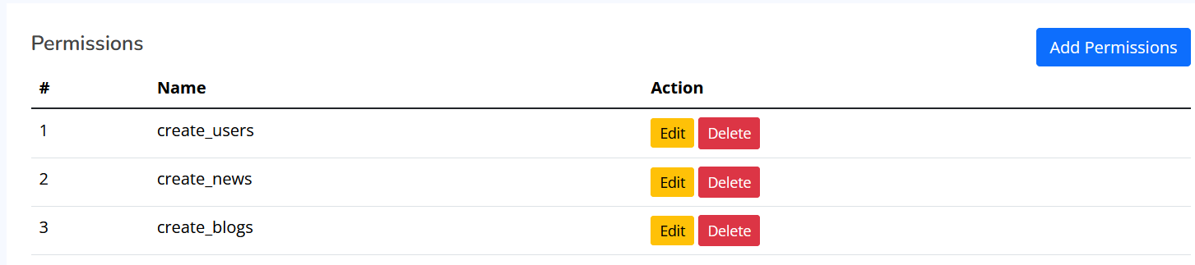

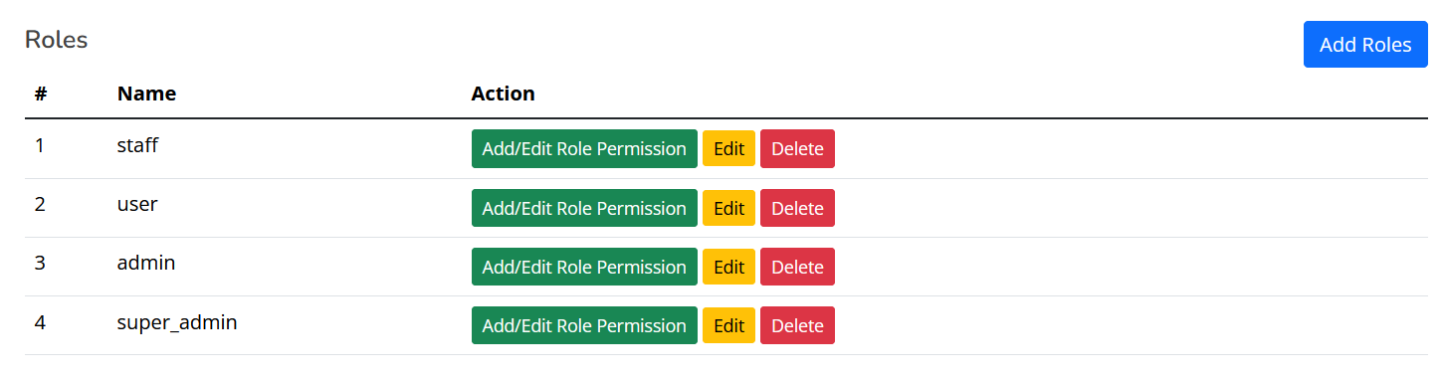

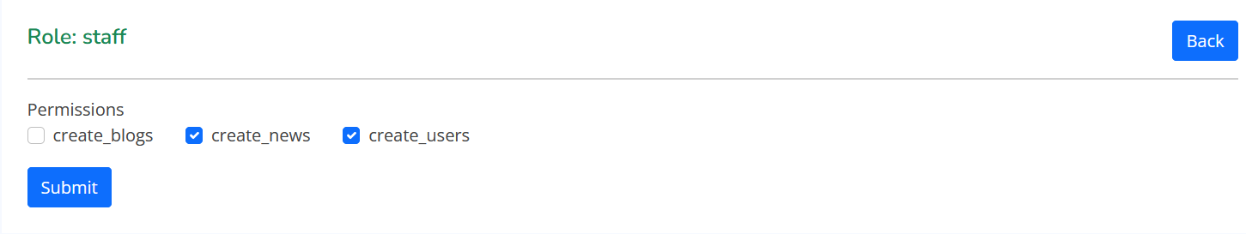

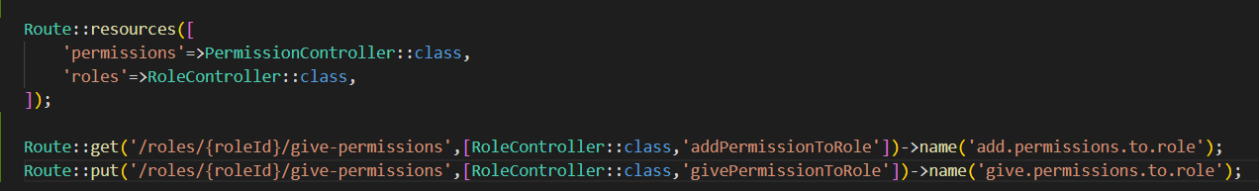

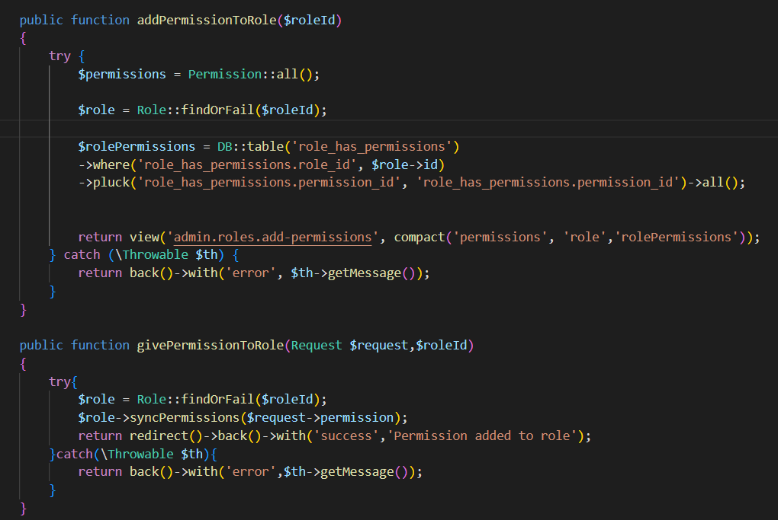

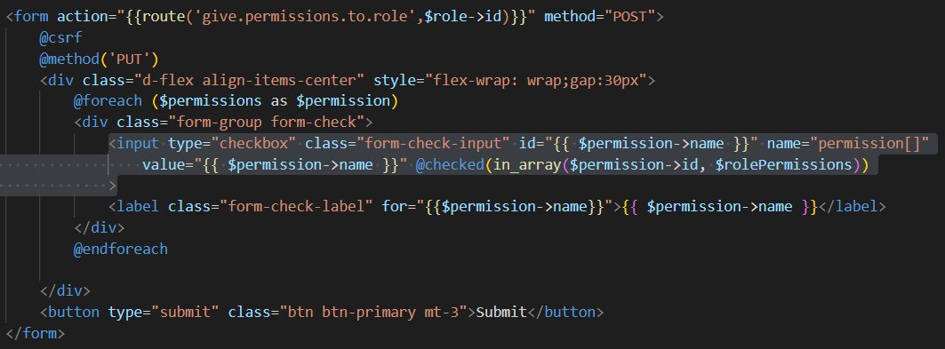

**Make user controller and perform crud operation:**

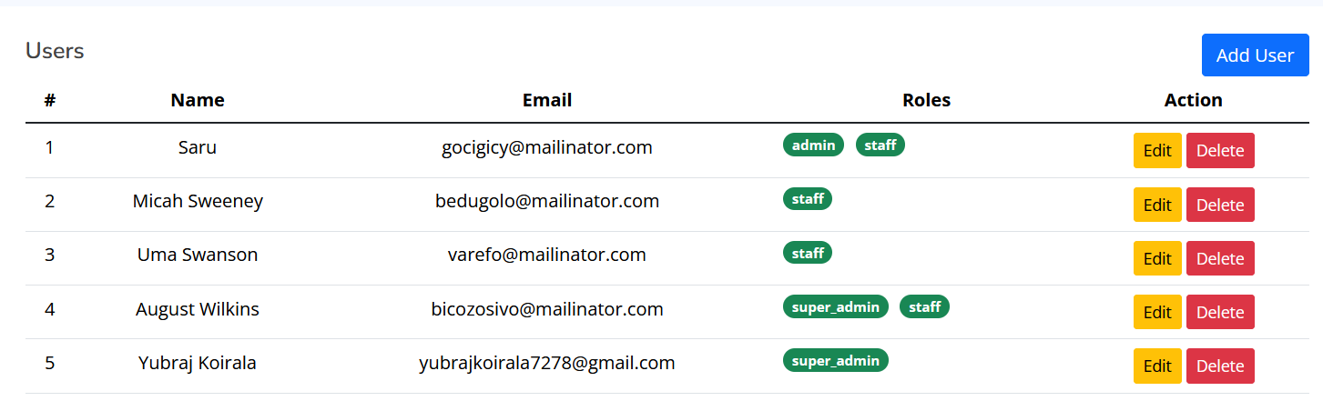

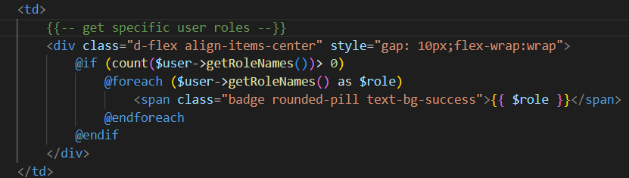

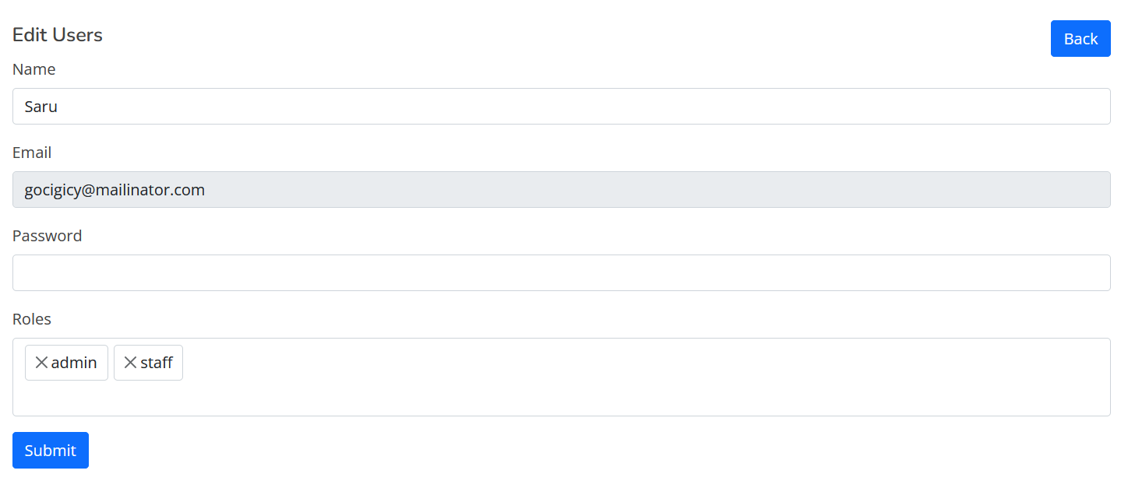

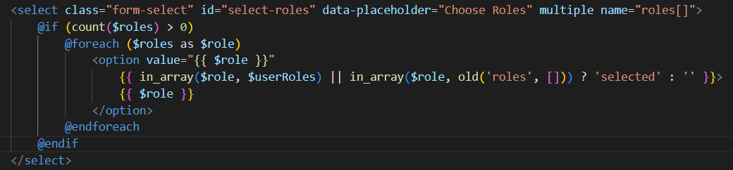

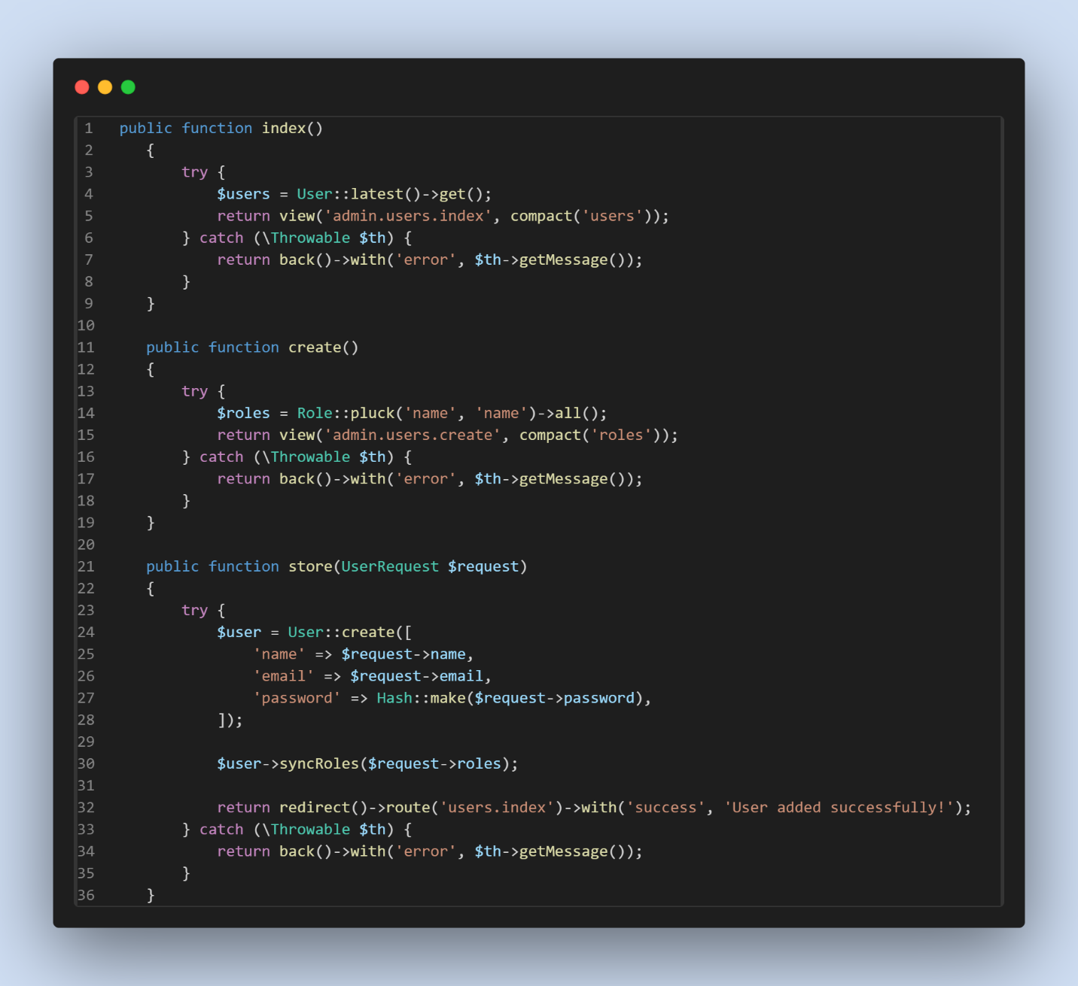

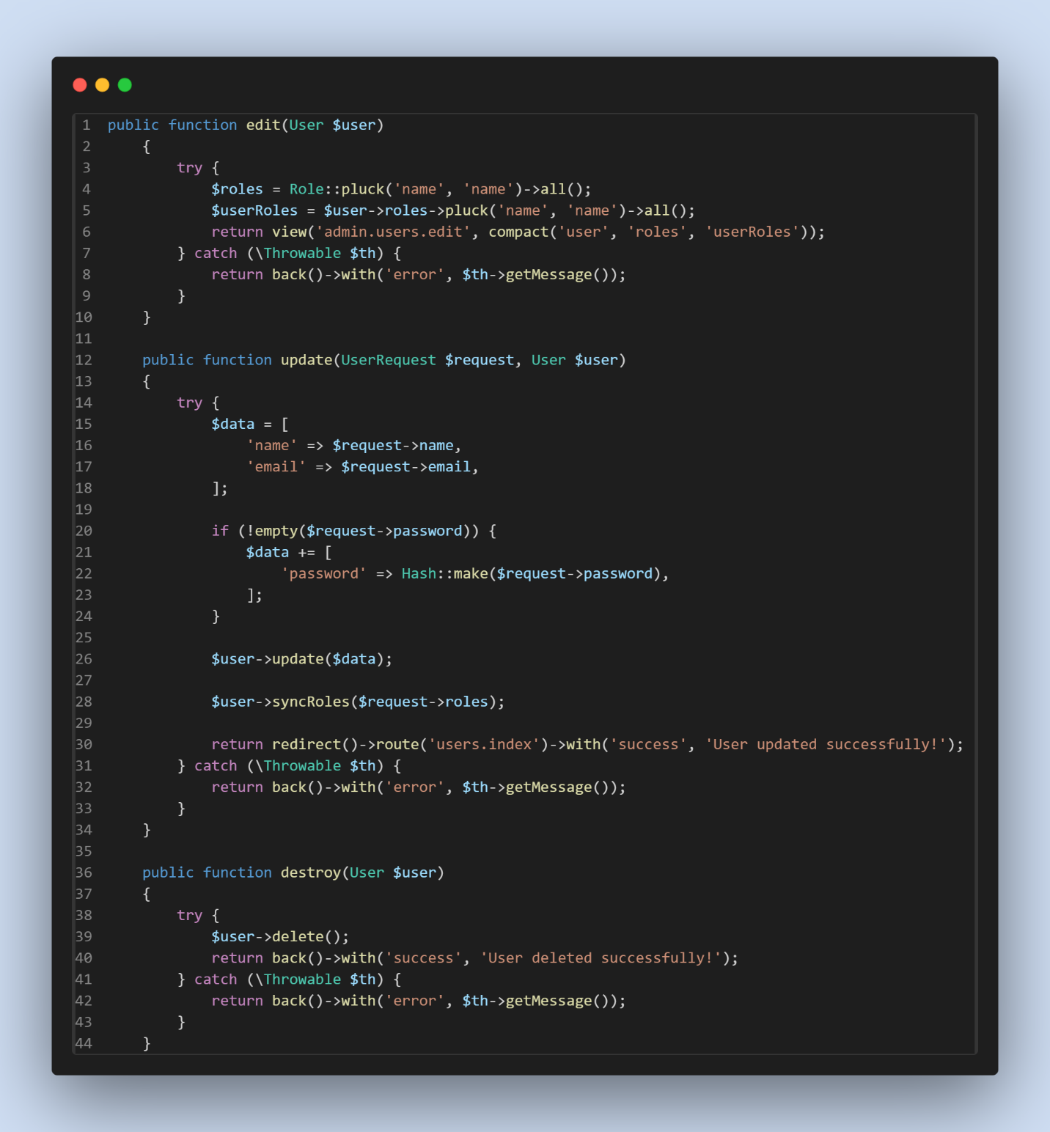

**Now, for roles and permissions:**

Step1:

<https://spatie.be/docs/laravel-permission/v6/basic-usage/middleware>



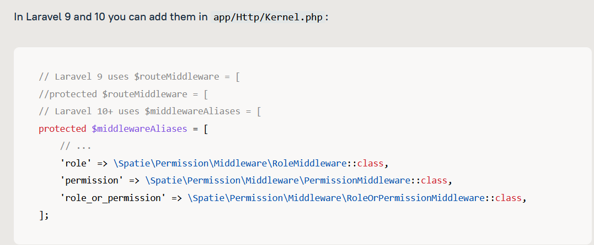

Step2:

In admin.php/web.php

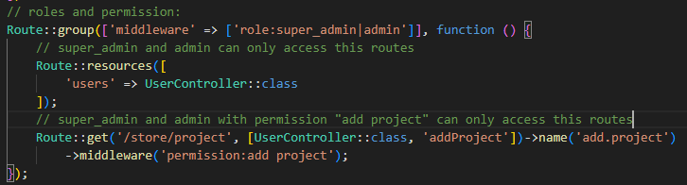

**Roles and permission in resource controller:** Step 1:

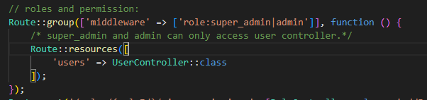

Step 2: (user controller)

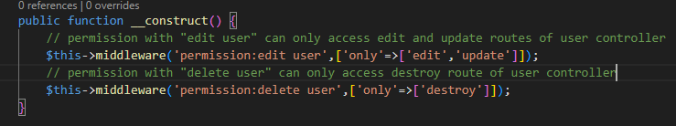

**Standard way to write the above roles and permission codes:**

Step 1: Kernel.php



Step 2: admin.php

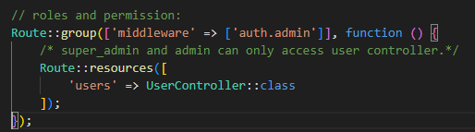

Step 3: AdminMiddleware.php

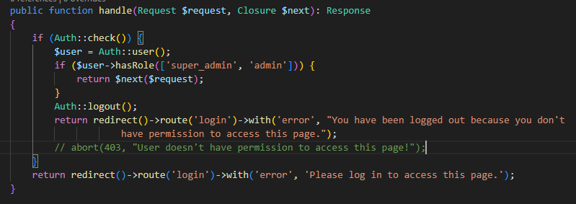

Step 4: Create RoleSeeder and AdminSeeder:

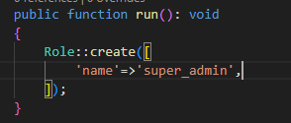

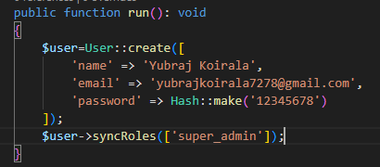

# **Laravel API CRUD:**

**Step:1**



**Step:2**



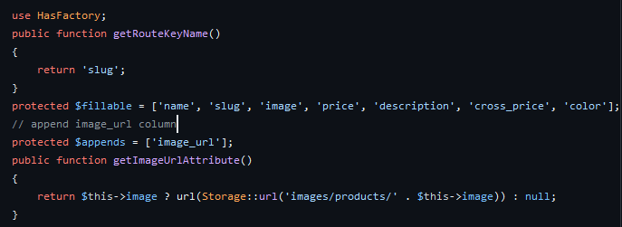

**Step 3:**

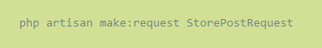

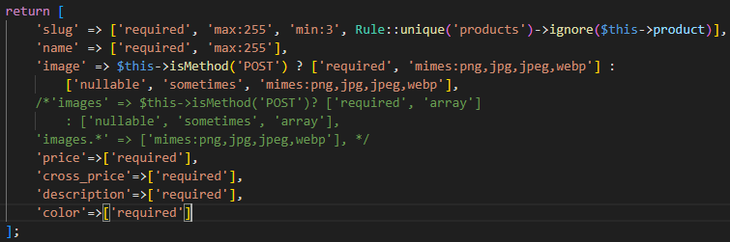

**Step 4:**

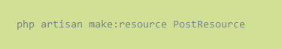

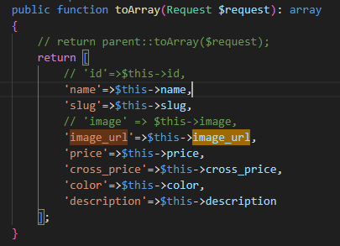

**Step 5:**



* **GET**

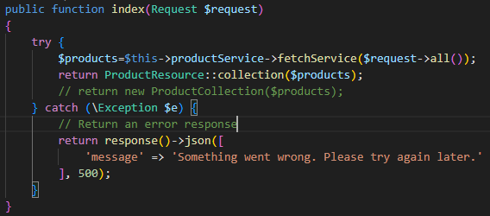

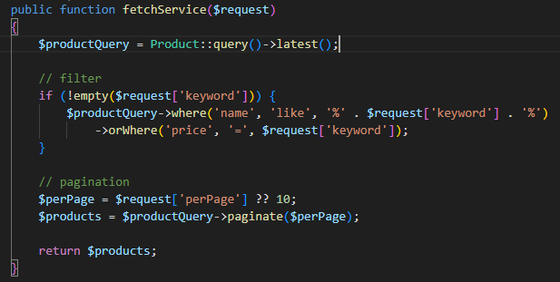

* **POST**

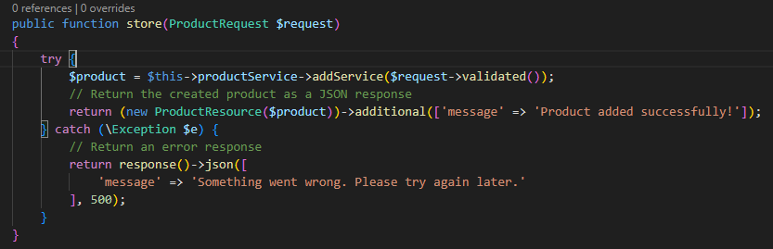

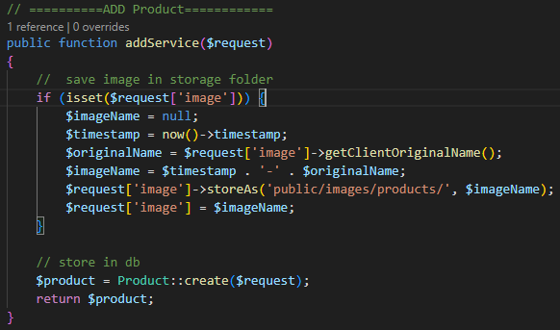

* **DELETE**

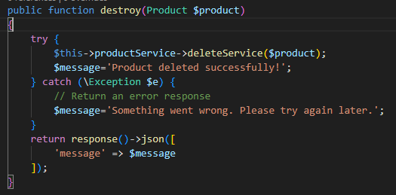

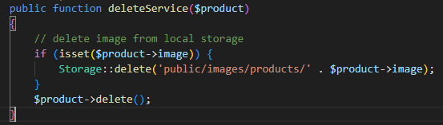

* **PUT/UPDATE**

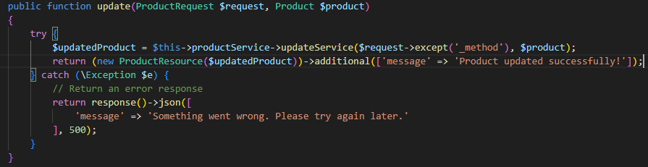

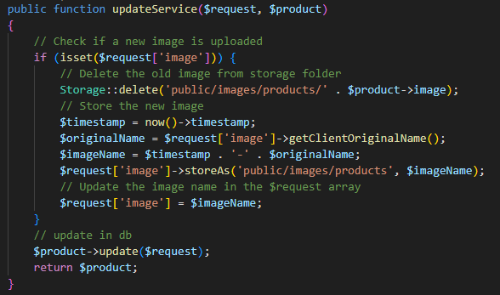

* **Get Single Product**

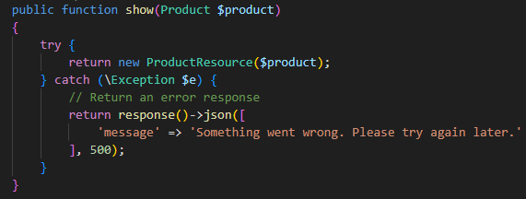

**Step 6:**

For Laravel 11 : php artisan install:api; php artisan route:cache; php artisan route:list

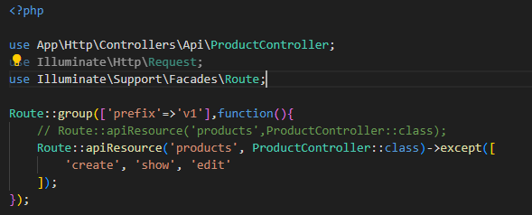

# **API Integration in VUE JS:**

**Step 1: (Project Setup References)**

<https://github.com/yubrajkoirala7278/laravel-vue-api-crud>

**Step 2: (.env.development)**

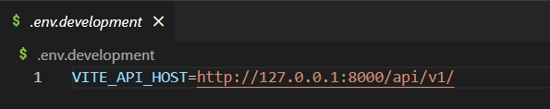

**Step 3: (service.js)**

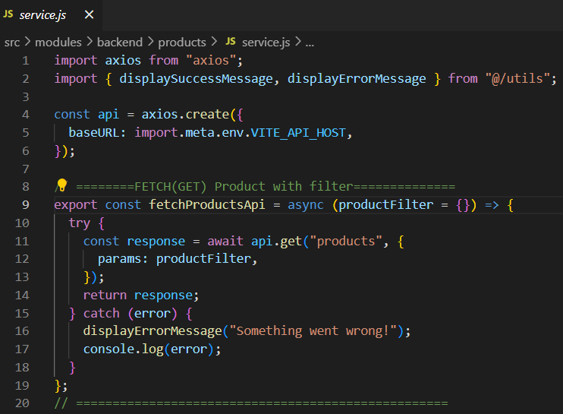

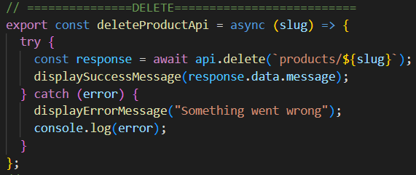

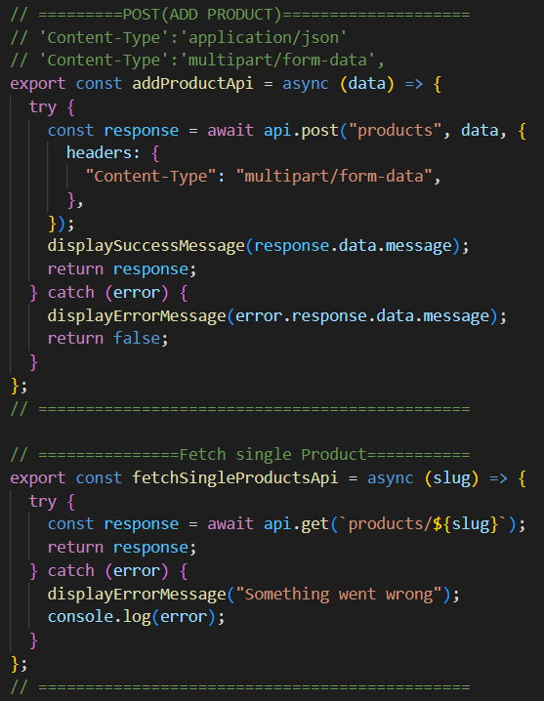

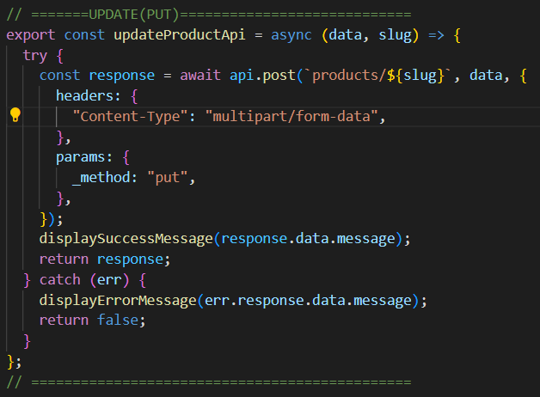

**Step 4: (store.js)**

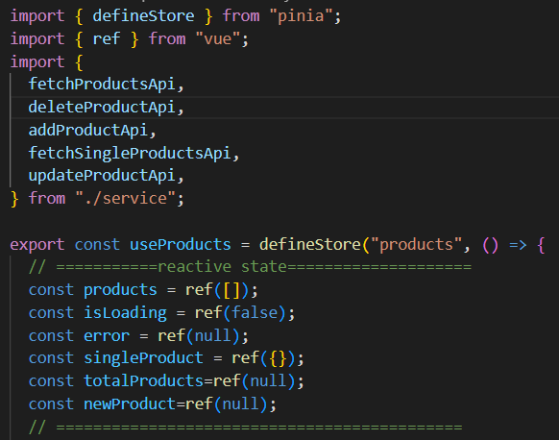

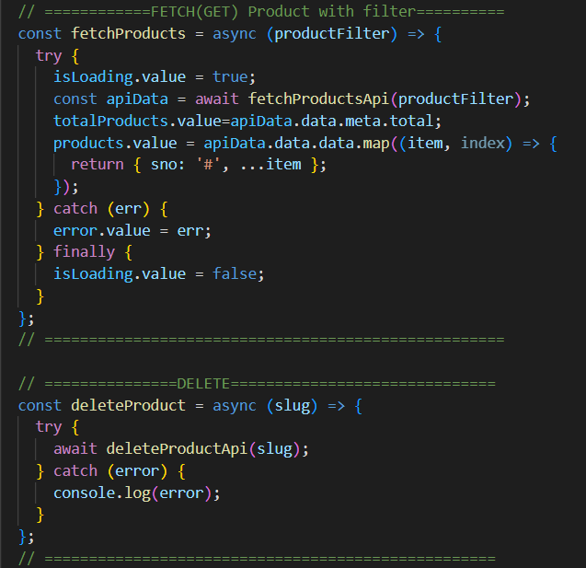

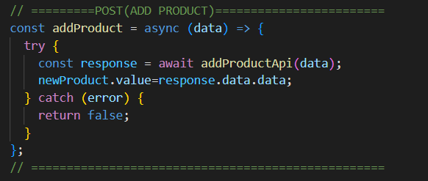

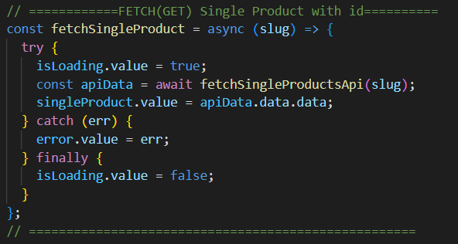

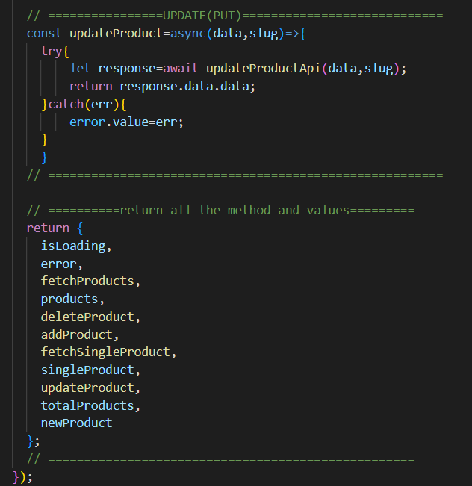

**Step 5: (utils.js)**

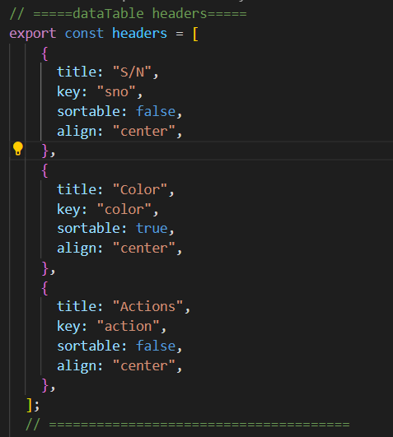

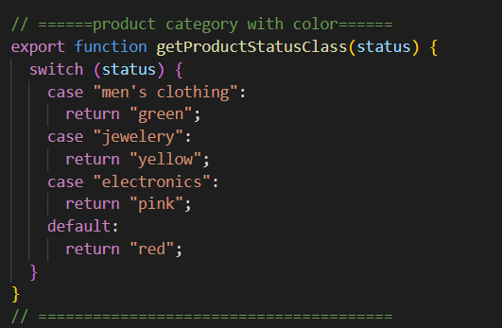

**Step 6: (product_view.vue)**

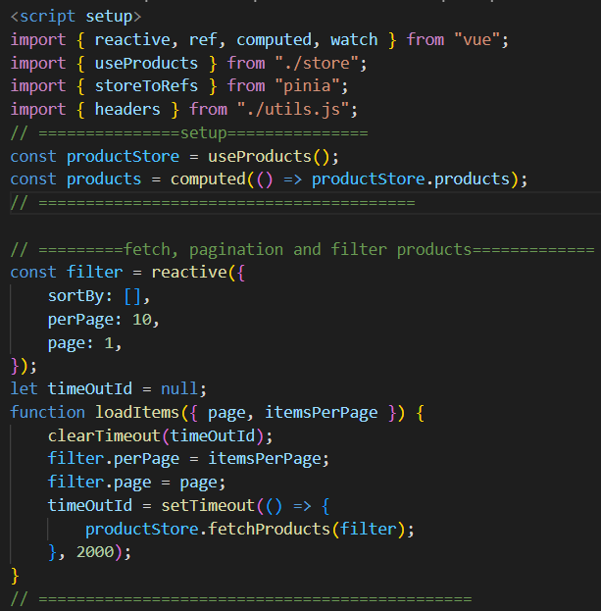

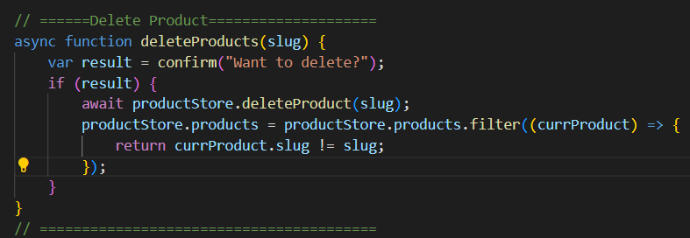

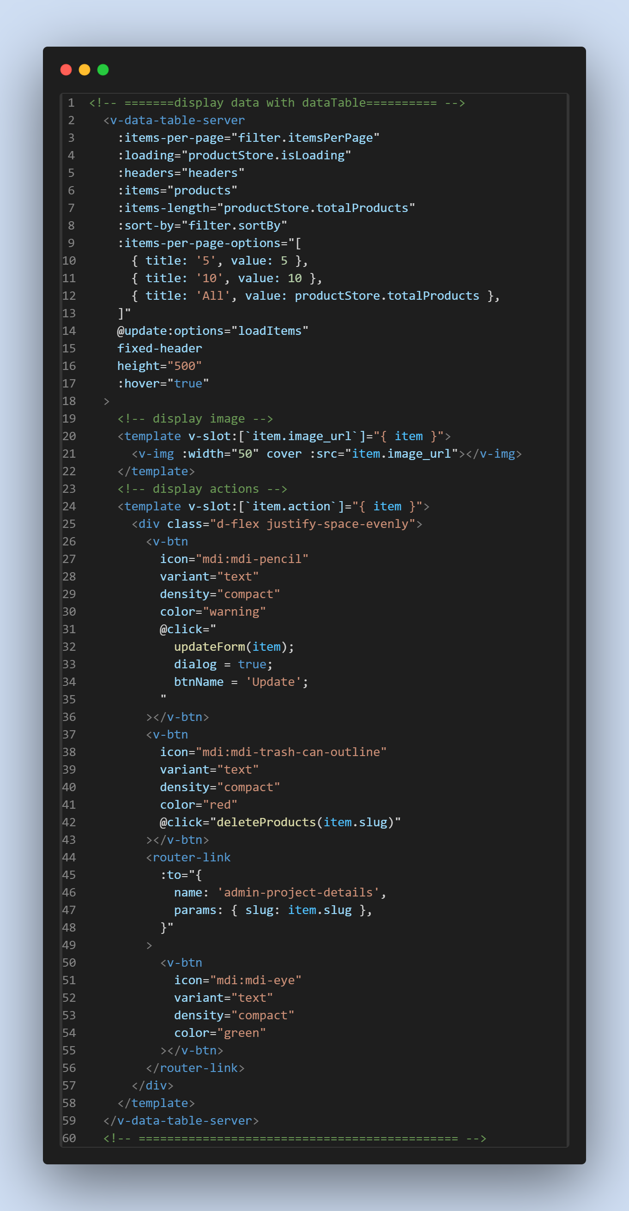

<!-- ==========Add/Update Product=================== -->

  <div class="text-start pa-4">

    <v-btn

      @click="

        resetForm();

        dialog = true;

        btnName = 'Submit';

      "

      color="green"

      class="text-capitalize"

    >

      Add Product

    </v-btn>

    <v-dialog v-model="dialog" width="auto" persistent scrollable>

      <v-card max-width="700" min-width="700" title="Add Product">

        <!-- form -->

        <v-form :valid="valid" @submit.prevent="submit" ref="productForm">

          <v-container>

            <v-row>

              <!-- name -->

              <v-col cols="12">

                <v-text-field

                  v-model="product.name"

                  :rules="[rules.required]"

                  label="Product Name"

                ></v-text-field>

              </v-col>

              <!-- slug -->

              <v-col cols="12">

                <v-text-field

                  v-model="product.slug"

                  :rules="[rules.required]"

                  label="Product Slug"

                ></v-text-field>

              </v-col>

              <!-- Image -->

              <v-col cols="12">

                <v-file-input

                  label="Product Image"

                  accept="image/png, image/jpeg, image/svg,image/jpg , image/gif"

                  prepend-icon=""

                  prepend-inner-icon="mdi-camera"

                  v-model="product.image"

                  show-size

                  counter

                  chips

                ></v-file-input>

              </v-col>

              <!-- price -->

              <v-col cols="12">

                <v-text-field

                  v-model="product.price"

                  :rules="[rules.price]"

                  label="Product Price"

                ></v-text-field>

              </v-col>

              <!-- cross price -->

              <v-col cols="12">

                <v-text-field

                  v-model="product.cross_price"

                  :rules="[rules.required]"

                  label="Product Cross Price"

                ></v-text-field>

              </v-col>

              <!-- Description -->

              <v-col cols="12">

                <v-textarea

                  v-model="product.description"

                  :rules="[rules.required]"

                  label="Product Description"

                ></v-textarea>

              </v-col>

              <!-- color -->

              <v-col cols="12">

                <v-text-field

                  v-model="product.color"

                  :rules="[rules.required]"

                  label="Product Color"

                ></v-text-field>

              </v-col>

            </v-row>

          </v-container>

          <v-card-actions>

            <v-spacer></v-spacer>

            <v-btn

              text="Cancel"

              @click="

                dialog = false;

                productForm.reset();

              "

              class="text-capitalize"

              variant="tonal"

              >Cancel</v-btn

            >

            <v-btn

              type="submit"

              :text="btnName"

              color="green"

              variant="flat"

              class="text-capitalize"

              :disabled="disableSubmitBtn"

              >Submit</v-btn

            >

          </v-card-actions>

        </v-form>

      </v-card>

    </v-dialog>

  </div>

  <!-- ========================================= -->

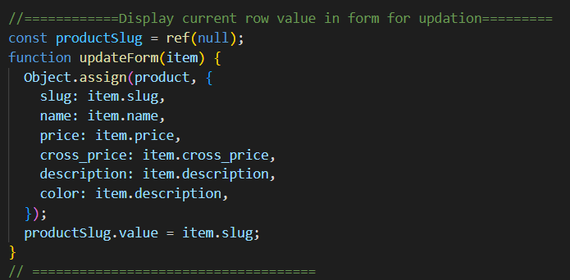

// =======Add Product======================

const disableSubmitBtn = ref(false);

const product = reactive({

  slug: null,

  name: null,

  image: null,

  price: null,

  cross_price: null,

  description: null,

  color: null,

});

// rules

const rules = {

  required: (v) => !!v || "Required",

  price: (v) => (!!v && v > 10) || "Amount must be greater than 10",

};

// generate automatic slug from name of product

watch(

  () => product.name,

  (newValue) => {

    product.slug = generateSlug(newValue);

  }

);

function generateSlug(text) {

  if (text != null) {

    return text.trim().toLowerCase().replace(/\s+/g, "-");

  }

  return null;

}

// submit form if validated

const productForm = ref(null);

const dialog = ref(false);

const btnName = ref("");

const { valid } = storeToRefs(productForm);

function submit() {

  productForm.value.validate().then(async ({ valid }) => {

    if (valid) {

      disableSubmitBtn.value = true;

      if (btnName.value == "Submit") {

        // ----------add product-----------

        let response = await productStore.addProduct(product);

        // append in frontend

        if (response != false) {

          products.value.unshift({ sno: "#", ...productStore.newProduct });

          dialog.value = false;

        }

      } else {

        // ----------update product-----------

        let response = await productStore.updateProduct(

          product,

          productSlug.value

        );

        // update in frontend

        if (response != false) {

          productStore.products = productStore.products.map((currProduct) => {

            if (currProduct.slug == productSlug.value) {

              return { sno: "#", ...response }; // Replace the object with updatedObject

            }

            return currProduct; // Keep the original object if it doesn't match the ID

          });

          dialog.value = false;

        }

      }

      disableSubmitBtn.value = false;

    }

  });

}

// reset form

const resetForm = () => {

  Object.assign(product, {

    slug: null,

    name: null,

    image: null,

    price: null,

    cross_price: null,

    description: null,

    color: null,

  });

};

// ========================================

**Step 7: (view single product)=>product_details.vue**

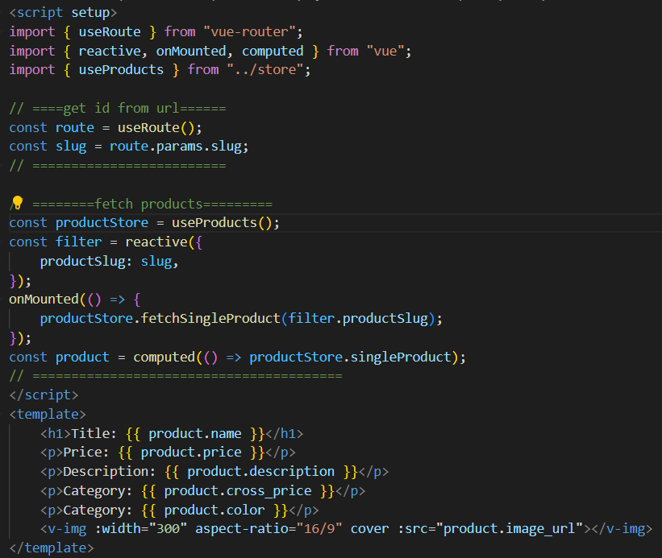

**Step 8: (router/index.js)**

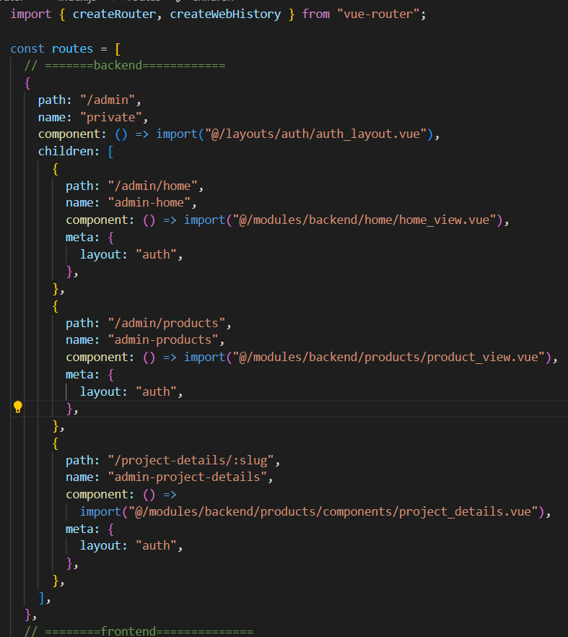

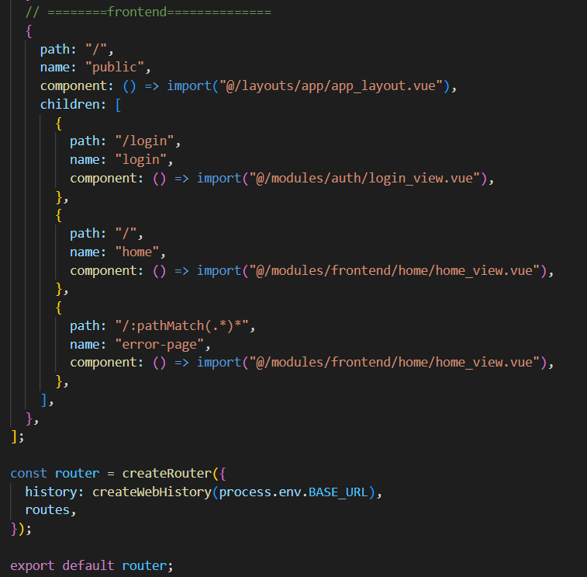

**Step 9: Data Table with no pagination**

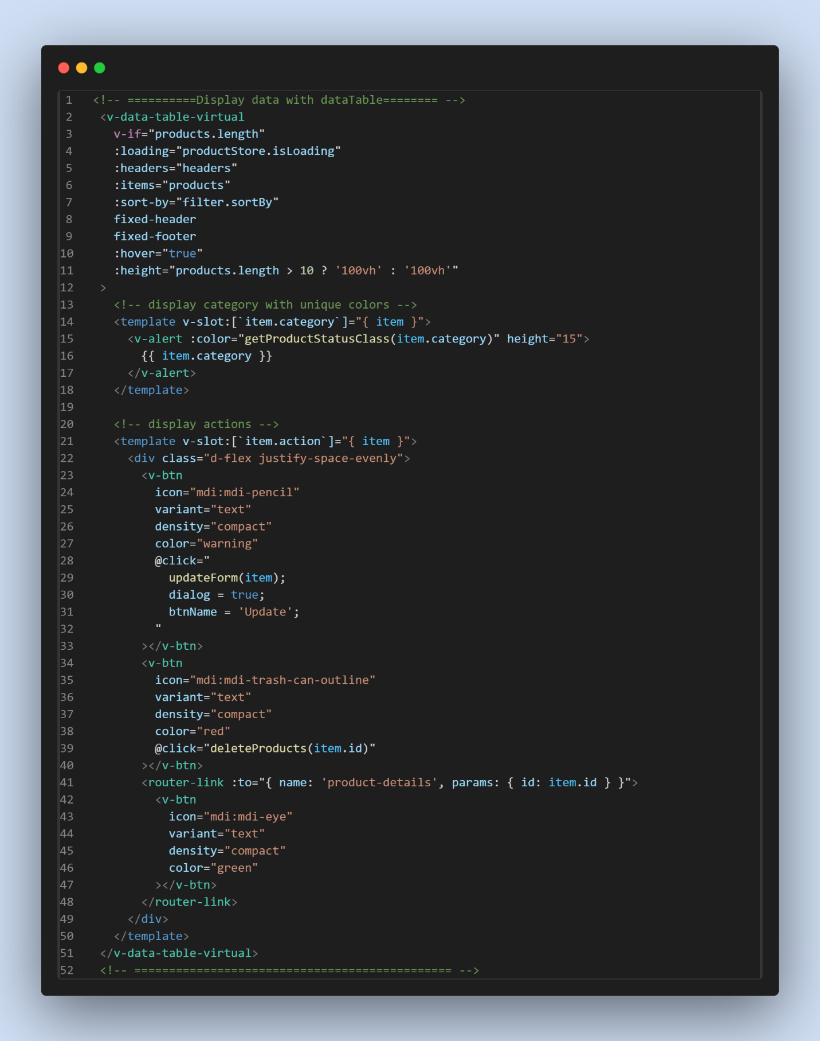

# **Authentication using Laravel UI Package:**

## 















Get password from security<2-step-verification<App Passwords

# **Middleware:**













<https://amanj0314.medium.com/how-to-use-laravel-middleware-to-protect-your-application-1c76aa0acded>

# **Spatie user Roles & Permission management:**

<https://spatie.be/docs/laravel-permission/v6/installation-laravel>













**Make Permission and Role Controller and do crud operation:**













**Make user controller and perform crud operation:**













**Now, for roles and permissions:**

Step1:

<https://spatie.be/docs/laravel-permission/v6/basic-usage/middleware>





Step2:

In admin.php/web.php



**Roles and permission in resource controller:** Step 1:



Step 2: (user controller)



**Standard way to write the above roles and permission codes:**

Step 1: Kernel.php



Step 2: admin.php



Step 3: AdminMiddleware.php



Step 4: Create RoleSeeder and AdminSeeder:





# **Morph Many (Comments):**

## **Make comment migration and model**

## **In CommentService.php**

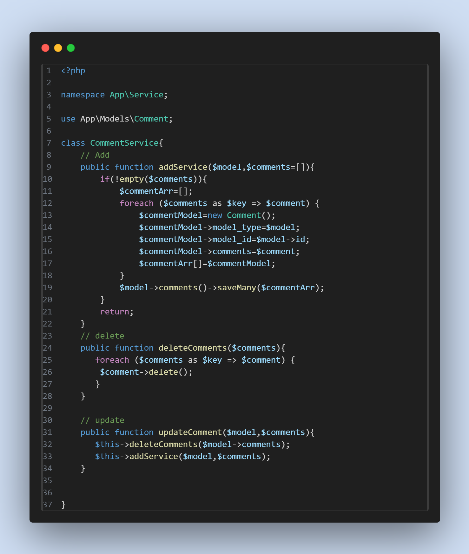

## **Comment Migration:**

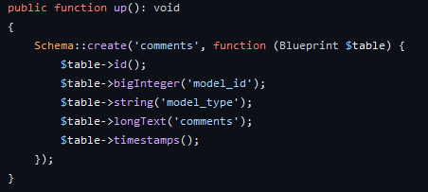

## **In any model you want to use**

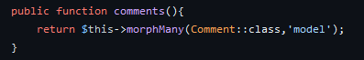

# **MorphOne Image:**

# composer require intervention/image

# 

<?php

namespace App\Service;

use App\Models\Image;

use Illuminate\Support\Facades\Storage;

use Intervention\Image\ImageManager;

use Illuminate\Support\Str;

class ImageService

{

    // Method to add image to a model

    public function saveImage($model, $image, $directory)

    {

        // Check if there are images to save

        if (!empty($image)) {

            $directory = 'public/images/' . $directory;

            // Create directory if it doesn't exist

            $this->makeDirectory($directory);

            // Generate unique filename

            $imageNames = $this->makeName($image);

            // Move and resize image

            $this->moveImage($image, $directory, $imageNames['saveName'], 1024, 720);

            // Create a new Image model instance

            $imageModel = new Image();

            // Assign model type (e.g., User, Product, etc.)

            $imageModel->model_type = $model;

            // Assign model ID

            $imageModel->model_id = $model->id;

            // Assign filename

            $imageModel->filename = $imageNames['saveName'];

            // Assign location

            $imageModel->location = $directory;

            // Save the image in the database

            $model->image()->save($imageModel);

        }

        return; // Return nothing

    }

    // Method to create a directory if it doesn't exist

    private function makeDirectory($path)

    {

        if (!Storage::exists($path)) {

            Storage::makeDirectory($path);

        }

        return; // Return nothing

    }

    // Method to generate a unique filename for an image

    public function makeName($image, $type = null)

    {

        // Get the original filename

        $originalName = Str::replace(' ', '-', trim($image->getClientOriginalName()));

        // Limit the filename length

        $NameWithoutExtension = Str::limit(pathinfo($originalName, PATHINFO_FILENAME), 200);

        // Generate a unique save filename

        $saveName = time() . '-' . $NameWithoutExtension . '.' . $image->getClientOriginalExtension();

        return [

            'saveName' => $saveName, // Return the unique filename

            'originalName' => $originalName, // Return the original filename

        ];

    }

    // Method to move and resize an image

    public function moveImage($image, $directory, $saveName, $width = 544, $height = 356)

    {

        // Read and resize the image

        $image = ImageManager::gd()->read($image);

        $image = $image->resize($width, $height);

        $image = $image->toWebp(70);

        // Store the image in the specified directory

        return Storage::put($directory . '/' . $saveName, $image, [

            'visibility' => 'public',

        ]);

    }

    // Method to delete image

    public function deleteImage($image)

    {

        // Delete image from the database

        $image->delete();

        // Delete image from local storage

        $path = $image->location . '/' . $image->filename;

        Storage::delete($path);

    }

      // Method to update images for a model

      public function updateImage($model, $image, $directory, $deletePrevious = false)

      {

          // Check if there are new images to update

          if (!empty($image)) {

              // If deletePrevious flag is set to true, delete previous images

              if ($deletePrevious) {

                  $this->deleteImage($model->image); // Delete previous images

              }

              // Make the directory if it doesn't exist

              $this->makeDirectory($directory);

              // Save new images

              $this->saveImage($model, $image,  $directory);

          }

      }

}

## **In BlogService:**

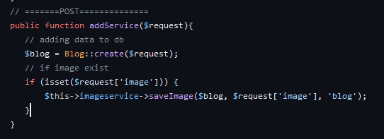

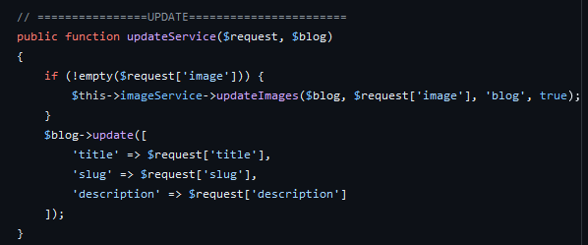

## **In any model:**

## 

# **MorphMany Images:**

<?php

namespace App\Service;

use App\Models\Image;

use Illuminate\Support\Str;

use Intervention\Image\ImageManager;

use Illuminate\Support\Facades\Storage;

class ImageService

{

    // Method to add images to a model

    public function addImages($model, $images = [], $directory)

    {

        // Save images to the specified directory

        $this->saveImages($model, $images, 'public/images/' . $directory);

        return; // Return nothing

    }

    // Method to save images to storage

    private function saveImages($model, $images, $directory)

    {

        if (!empty($images)) { // Check if there are images to save

            $imageArr = []; // Array to store image objects

            $this->makeDirectory($directory); // Create directory if it doesn't exist

            foreach ($images as $image) {

                $imageNames = $this->makeName($image); // Generate unique filename

                $this->moveImage($image, $directory, $imageNames['saveName'], 1024, 720); // Move and resize image

                // Create a new Image model instance

                $imageModel = new Image();

                // Assign model type (e.g., User, Product, etc.)

                $imageModel->model_type = $model;

                // Assign model ID

                $imageModel->model_id = $model->id;

                // Assign filename

                $imageModel->filename = $imageNames['saveName'];

                // Assign location

                $imageModel->location = $directory;

                // Add image to the array

                $imageArr[] = $imageModel;

            }

            // Save images in the database

            $model->image()->saveMany($imageArr);

        }

        return; // Return nothing

    }

    // Method to move and resize an image

    public function moveImage($image, $directory, $saveName, $width = 544, $height = 356)

    {

        // Read and resize the image

        $image = ImageManager::gd()->read($image);

        $image = $image->resize($width, $height);

        $image = $image->toWebp(70);

        // Store the image in the specified directory

        return Storage::put($directory . '/' . $saveName, $image, [

            'visibility' => 'public',

        ]);

    }

    // Method to generate a unique filename for an image

    public function makeName($image, $type = null)

    {

        // Get the original filename

        $originalName = Str::replace(' ', '-', trim($image->getClientOriginalName()));

        // Limit the filename length

        $NameWithoutExtension = Str::limit(pathinfo($originalName, PATHINFO_FILENAME), 200);

        // Generate a unique save filename

        $saveName = time() . '-' . $NameWithoutExtension . '.' . $image->getClientOriginalExtension();

        return [

            'saveName' => $saveName, // Return the unique filename

            'originalName' => $originalName, // Return the original filename

        ];

    }

    // Method to update images for a model

    public function updateImages($model, $images, $directory, $deletePrevious = false)

    {

        // Check if there are new images to update

        if (!empty($images)) {

            // If deletePrevious flag is set to true, delete previous images

            if ($deletePrevious) {

                $this->deleteImages($model->image); // Delete previous images

            }

            // Make the directory if it doesn't exist

            $this->makeDirectory($directory);

            // Save new images

            $this->saveImages($model, $images, 'public/images/' . $directory);

        }

    }

    // Method to delete images

    public function deleteImages($images)

    {

        foreach ($images as $image) {

            // Delete image from the database

            $image->delete();

            // Delete image from local storage

            $path = $image->location . '/' . $image->filename;

            Storage::delete($path);

        }

    }

    // Method to create a directory if it doesn't exist

    private function makeDirectory($path)

    {

        if (!Storage::exists($path)) {

            Storage::makeDirectory($path);

        }

        return; // Return nothing

    }

}

## **Laravel Module Package:**

Used to manage and organize big projects. Example: School Management System has Student,Teacher and Fees modules.

<https://nwidart.com/laravel-modules/v6/installation-and-setup>

* 1. composer require nwidart/laravel-modules
  2. php artisan vendor:publish --provider="Nwidart\Modules\LaravelModulesServiceProvider"
  3. In composer.json

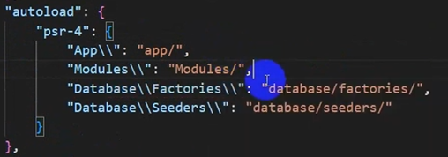

* 1. composer dump-autoload
  2. Now create a module which have its own Controller, Models, Views and Routes.

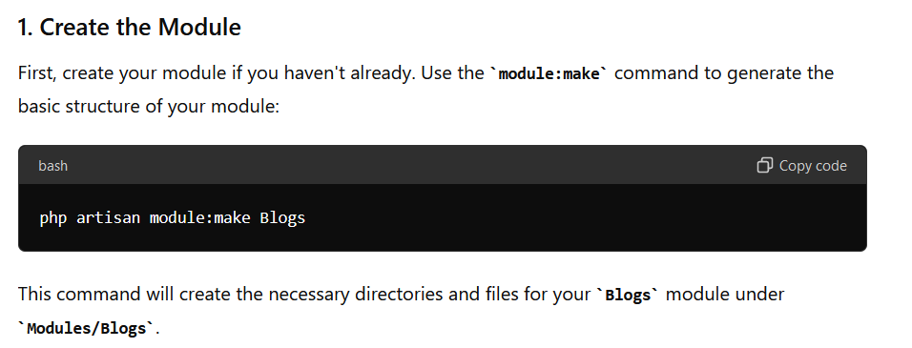

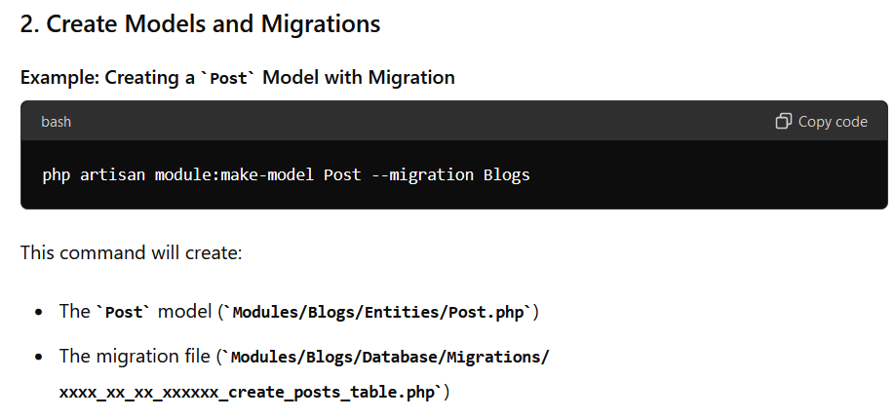

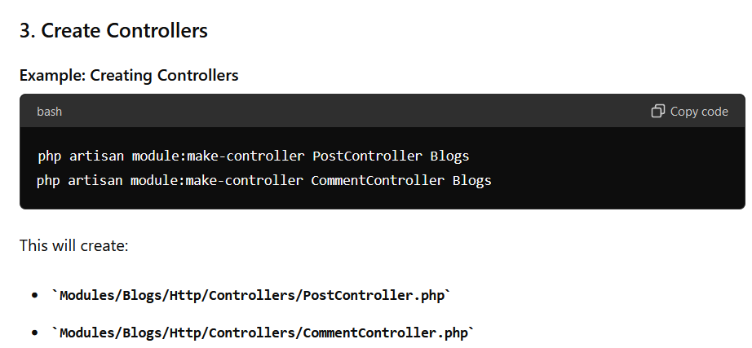

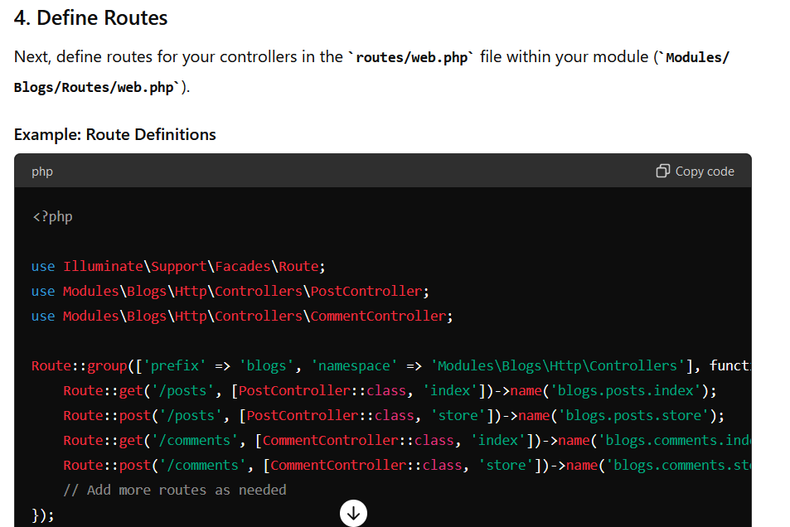

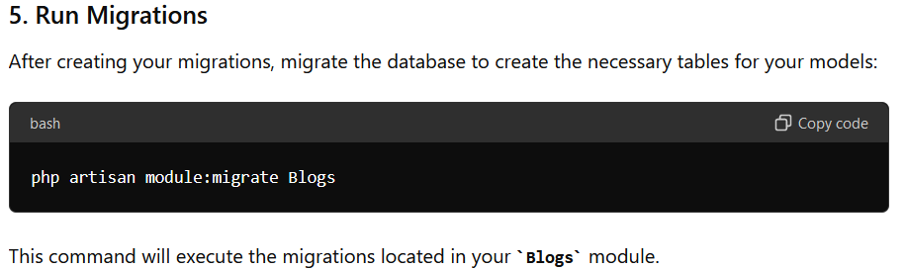

**Make request for validation in specific module:**



## **Laravel Repository Design Pattern:**

1. Create app/Repositories/Interfaces/CategoryRepositoryInterface.php file

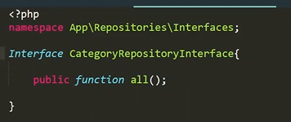

1. Create app/Repositories/CategoryRepository.php

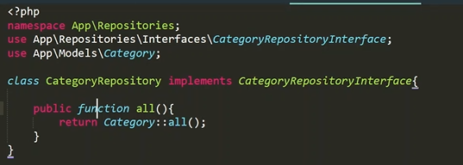

1. Inside CategoryController.php

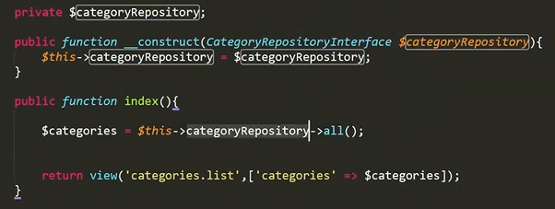

1. Inside AppServiceProvider.php

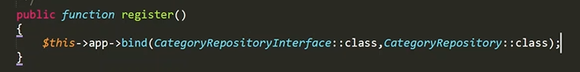

# **Event & Listener in Laravel:**

Laravel's events provide a simple observer pattern implementation, allowing you to subscribe and listen for various events that occur within your application.

**Task: If any user create a blog then send email to all the users that blog has been created and notify the admin that blog has been created. Here, When Blog is created (event occurred) then listener will listen the event and execute automatically.**

1. Create Event:

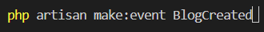

1. Inside your controller

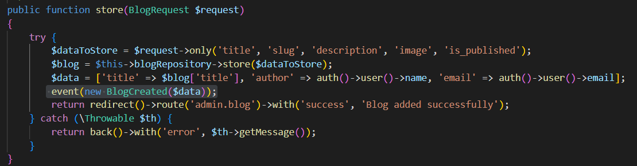

1. Inside BlogCreated.php

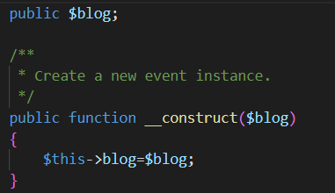

1. Make Listener NotifyUser(any name) to listen the BlogCreated event.



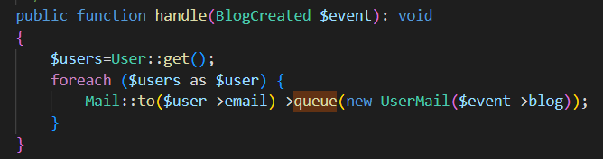

1. Inside EventServiceProvider.php

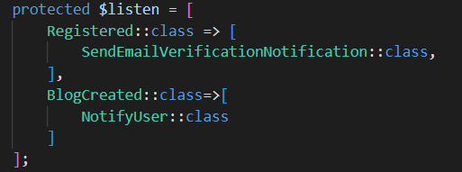

1. Make mail to send mail:

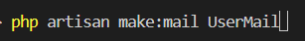

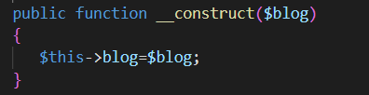

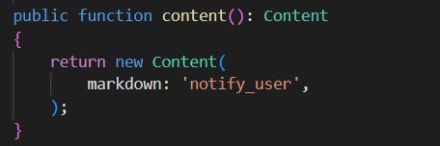

**Inside notify_user.blade.php**

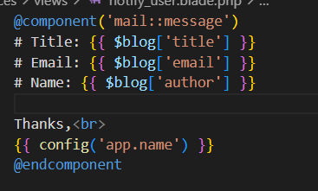

**Attach Image:**



1. Queues allow you to defer time-consuming tasks, such as sending emails or generating reports, to be processed in the background, freeing up your application to handle other requests.

**Php artisan queue:table**

**in .env**



Inside **UserMail.php**



**php artisan migrate**



# **Pusher For Real Time:**

Official docs:

<https://medium.com/@parthpatel0516/laravel-real-time-notifications-with-pusher-3ac72531e15>

1. Install Pusher

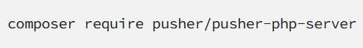

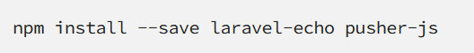

1. Uncomment below code from config/app.php

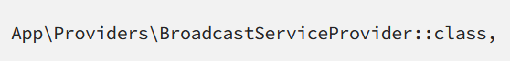

1. In .env



1. Uncomment below code from resources/js/bootstrap.js

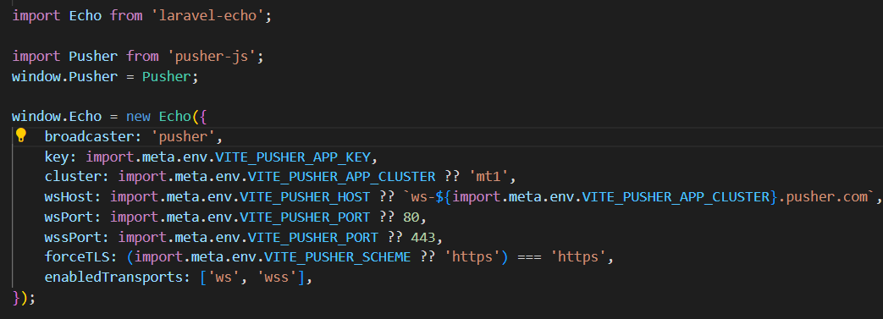

1. Get all the App Keys from <https://dashboard.pusher.com/>

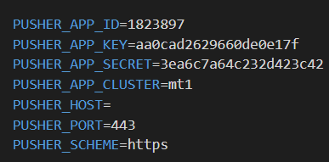

1. **Inside broadcasting.php**

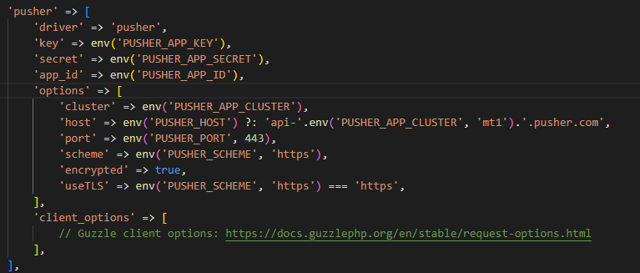

1. Create an event

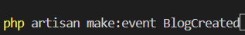

1. Inside call the event from your controller:

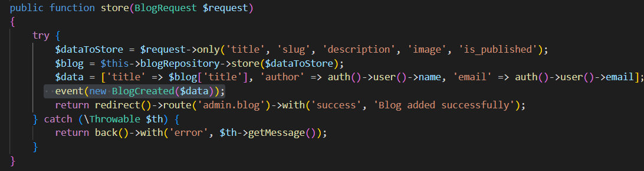

1. Inside your event:



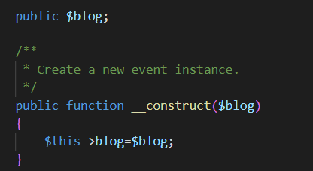

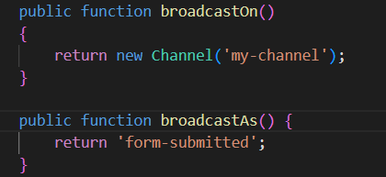

1. Inside any blade file where you want notification to be displayed:

->**You can get the below code from pusher dashboard in Getting Started.**

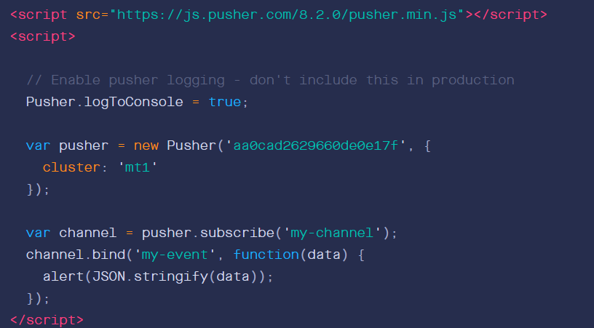

**Custom**

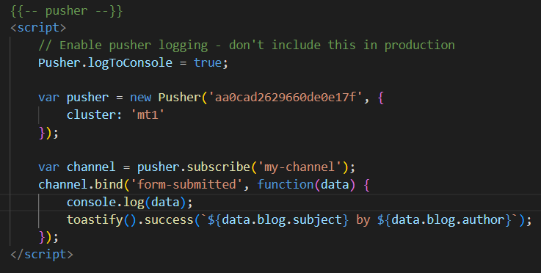

1. **php artisan queue:listen**

# **Real Time Bell Icon Notification Using Pusher & Livewire:**

1. Follow upto step 6 from above setup.
2. Create an event : php artisan make:event:CommissionEarned and notification php artisan make:notification CommissionEarnedNotification.
3. Call event and notification from controller/livewire component.

**Send Notification to only auth user:**

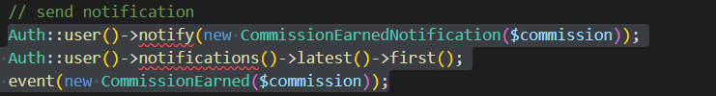

1. Inside CommissionEarned event:

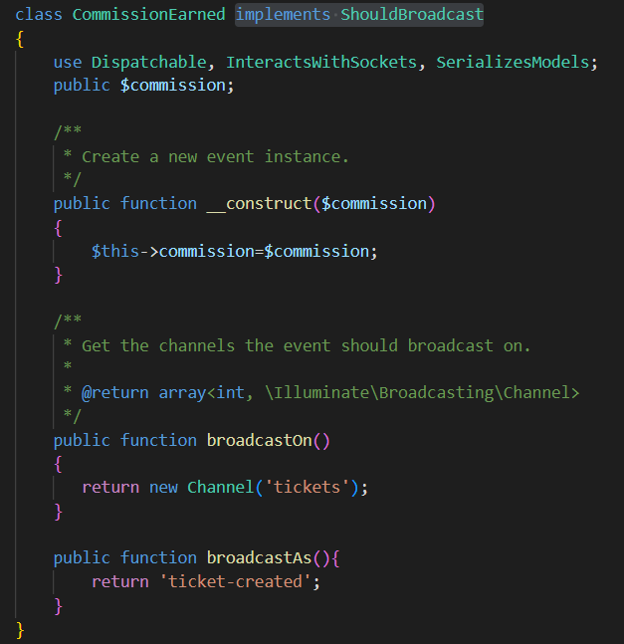

1. Inside CommissionEarnedNotification.php

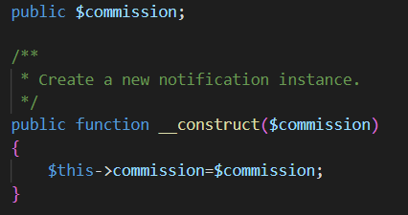

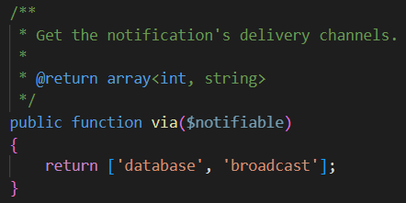

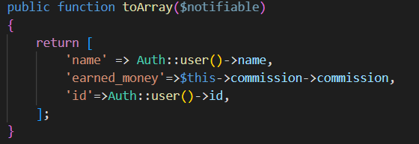

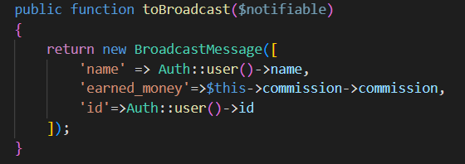

1. Inside master.blade.php

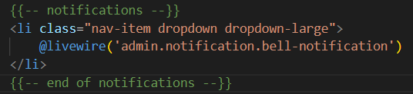

1. Create BellNotification.php livewire component.
2. Inside BellNotification.php

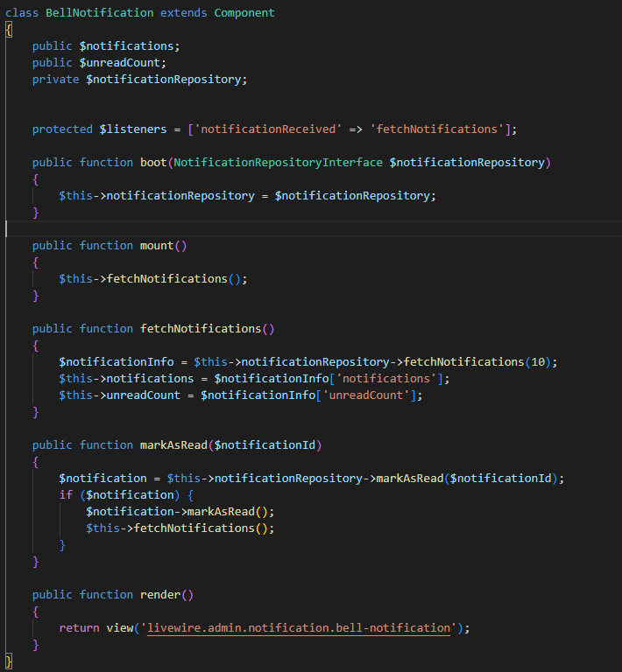

1. Inside NotificationRepository.php:

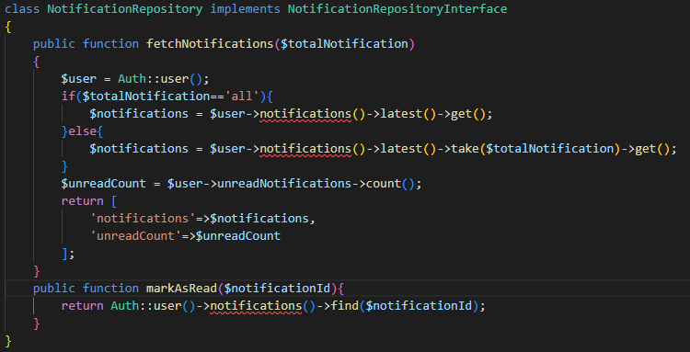

1. Inside bell-notification.blade.php

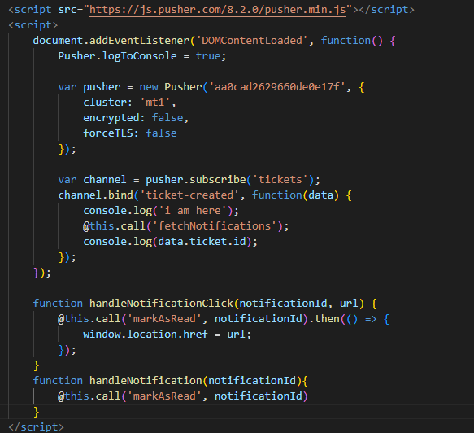

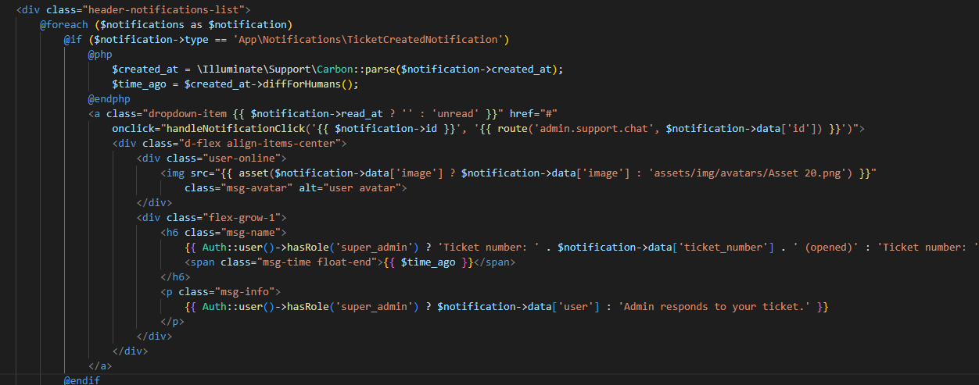

## **Bell Icon Notification Using Pusher and AJAX:**

1. Follow upto step 6 from above setup.
2. Create new event: php artisan make:event BlogCreated and notification php artisan make:notification PostCreatedNotification.
3. Inside your method where you want to send notification:

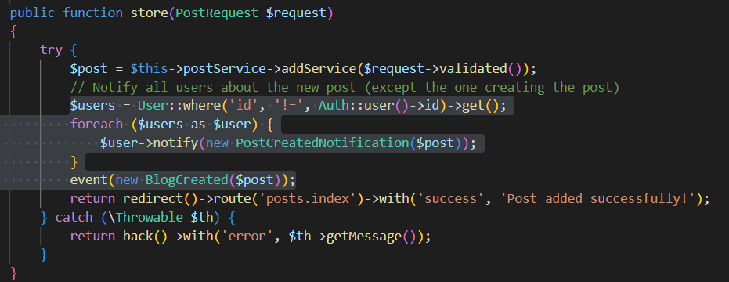

1. Inside BlogCreated event:

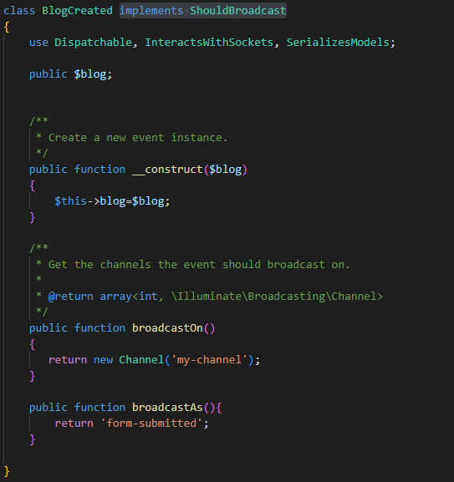

1. Inside PostCreatedNotification.php:

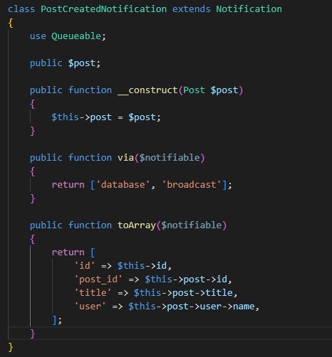

1. Inside master.blade.php

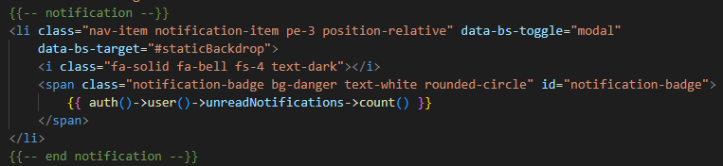

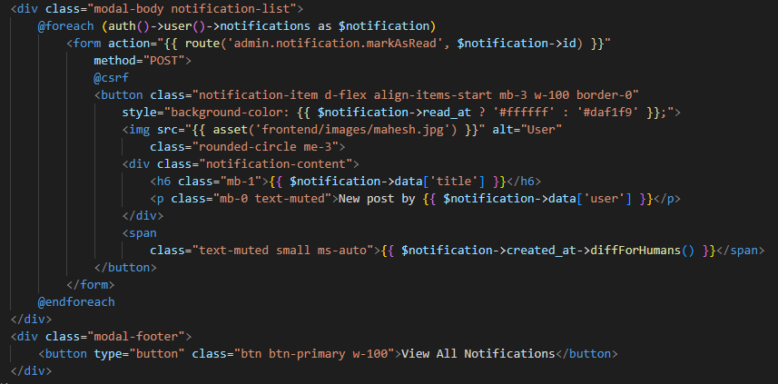

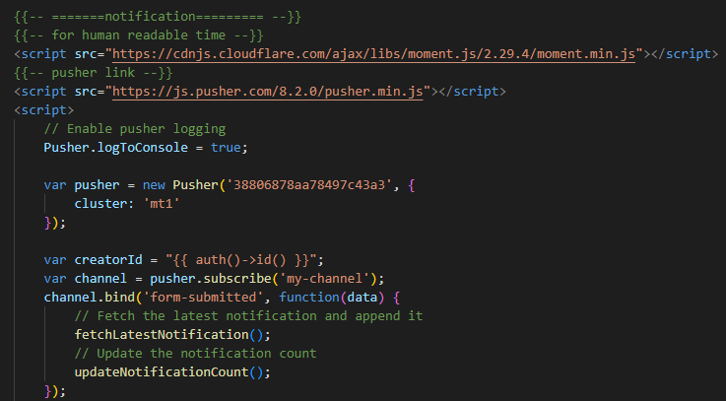

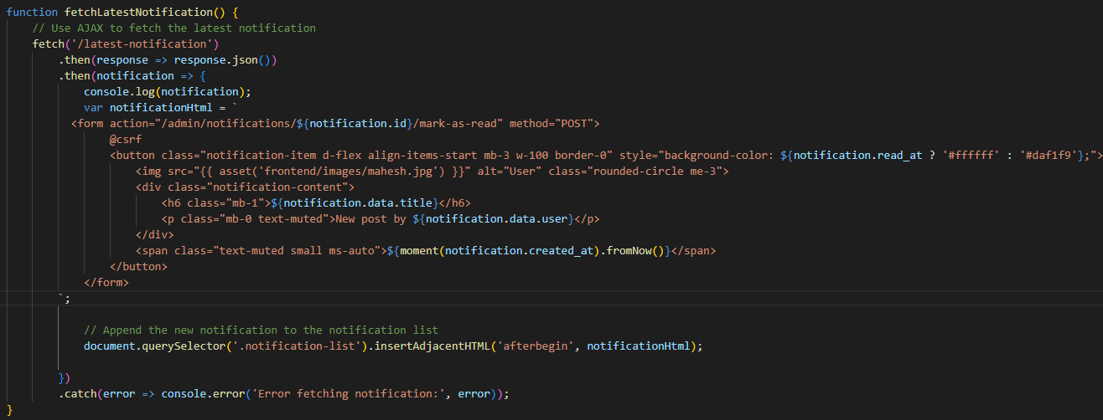

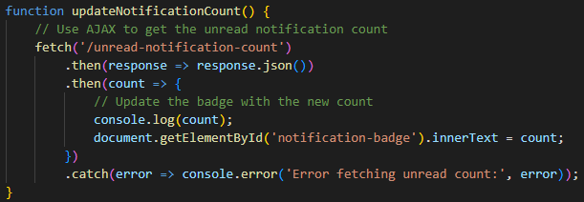

1. Inside web.php

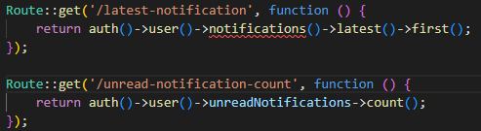

1. Inside NotificationController.php

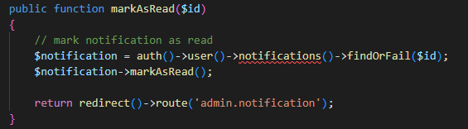

# **Livewire:**

1. Follow below docs:

<https://livewire.laravel.com/docs/quickstart>

1. Life cycle hooks in livewire:

<https://laravel-livewire.com/docs/2.x/lifecycle-hooks>

# **Twilio ( Send msg in mobile):**

In the context of a Laravel application, Twilio is often used to implement features like SMS messaging, voice calls, and two-factor authentication in mobile phone.

Read the docs and do by yourself:

<https://fajarwz.com/blog/sending-sms-in-laravel-using-twilio-a-step-by-step-tutorial/>

<https://medium.com/@laraveltuts/laravel-10-send-sms-using-twilio-tutorial-example-2676c20f25f8>

**MailChimp:**

Mailchimp is an all-in-one marketing platform that allows businesses and organizations to manage their email marketing campaigns, create landing pages, and track their marketing performance. It is a popular email marketing tool that enables businesses to send bulk emails to their subscribers and customers, automate email campaigns, and analyze the results of their email marketing efforts.

<https://github.com/spatie/laravel-newsletter>

<https://www.youtube.com/watch?v=cDhMcvZOcPA>

# **Laravel Package Development (Own Custom Package):**

1. Make your-project/packages/laraphant/contactform/src folder
2. In contactform directory write command: **composer init**

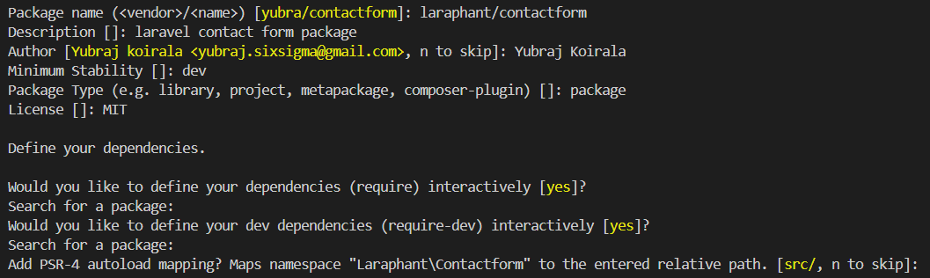

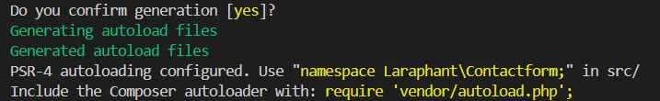

1. Below folder structure will be created:

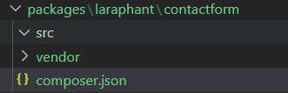

1. Now, In your main project directory make provider:



1. Move this ContactFormServiceProvider to your custom package src folder /src/ContactFormServiceProvider.php and modify namespace like below:

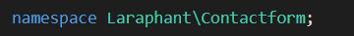

1. Write below code in your custom package composer.json

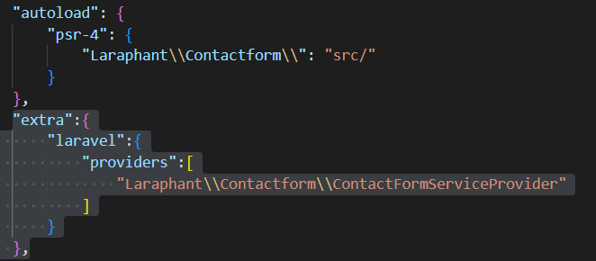

1. In your main composer.json file:

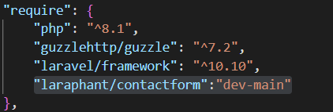

And create repositories array with object:

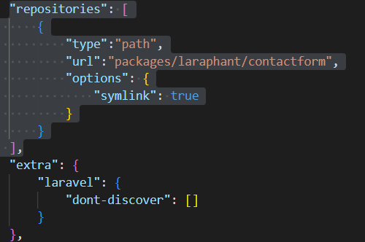

1. Write **composer update** command.
2. Setup has been completed to make your package.
3. Create file in contactform/routes/web.php and then you can define your own routes inside your package:

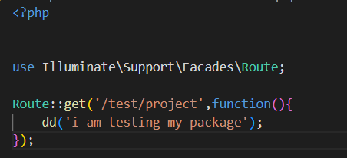

1. To use this routes load routes in your ContactFormServiceProvider.php

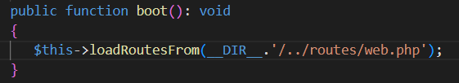

1. Make controller **php artisan make:controller ContactFormController** and move this file to laraphant/contactform/src/Http/Controllers/ContactFormController.php and modify namespace as below:



1. You can create your blade files in laraphant/contactform/resources/views/create.blade.php
2. To use the blade files you should load blade files in ContactFormServiceProvider.php like below:

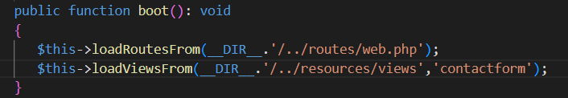

1. Now, you can use blade file from your controller like below:

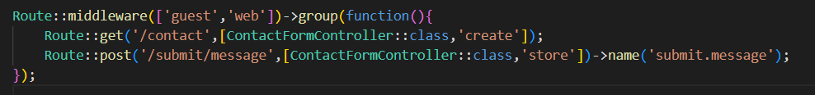

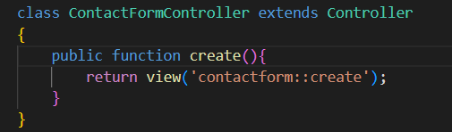

1. Make form in create.blade.php like below:

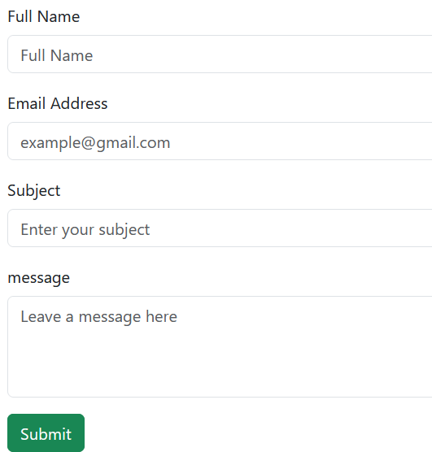

1. When submit called the store method of ControllerFormController.php:

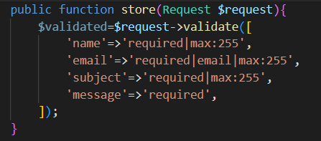

1. Create contact model with migration : **php artisan make:model Contact –m**  and move Contact.php model in /src/Models/Contact.php folder of your package and then change namespace like below:

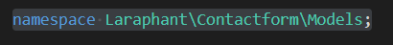

1. Move the contacts migration from original directory to /contactform/database/migrations/your_migrations_file folder.

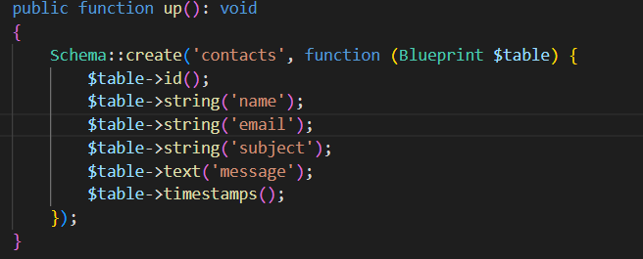



1. Load migrations in ContactFormServiceProvider.php

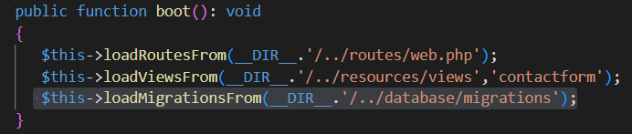

1. Contact us details have been saved into db. Now, the next task is to send email notification to admin that someone wants to contact him.
2. Make config.php file in contactform/config/config.php:

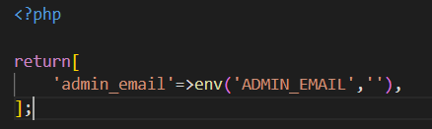

1. Inside .env file:

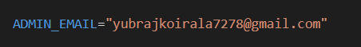

1. Load config file inside ContactFormServiceProvider.php:

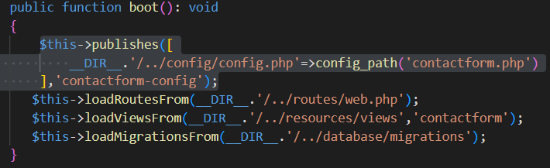

And then write command:

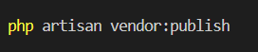

Since we have created **contactform-config** so it will be listed like below:



Here the number is 18 so enter 18 and then enter.

1. Make mail: **php artisan make:mail InqueryEmail** and then move InqueryEmail.php to contactform/src/Mail/InqueryEmail.php folder. And change namespace as below:

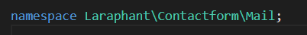

1. After storing the contact information use mail to send mail to admin:

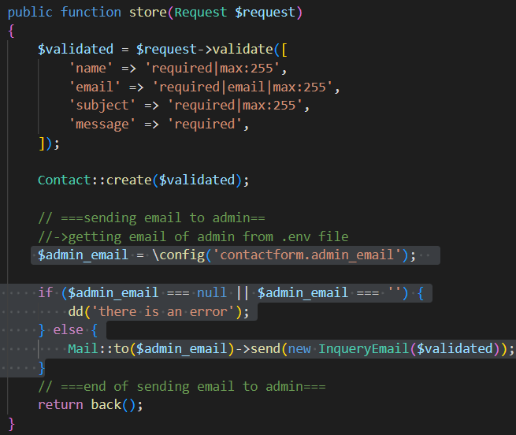

1. Inside InqueryEmail.php: (to configure how to send email is already described above)

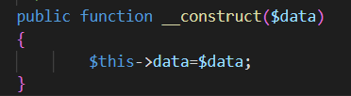

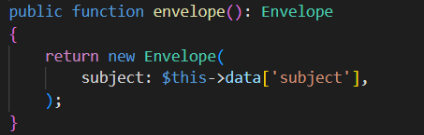

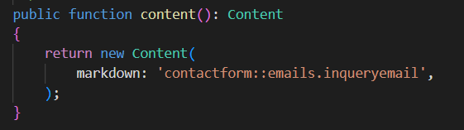

1. Now, Create blade file in contactform/resources/views/emails/inqueryemail.blade.php:

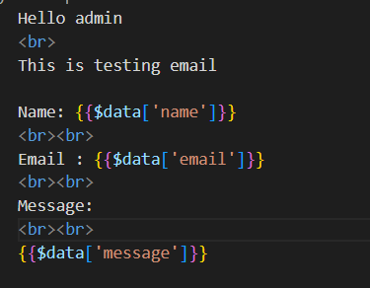

1. Congratulations! Package has been created successfully.
2. Publishing package so that it can be used any projects. Follow below steps to publish your package.
3. Add .gitignore in contactform/.gitignore:

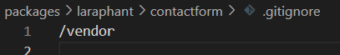

1. Also create README.md in contactform/README.md to write brief description about your package.

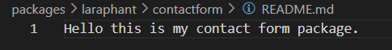

1. Go to your package directory:

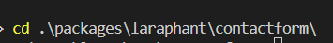

git init

git checkout –b main

git add .

git commit –m “contact form package has been completed”

git tag 1.0.0

Create new repository in github

git remote add origin <https://github.com/yubrajkoirala7278/contactform.git>

git push –u origin --all

1. After pushing code to github go to <https://packagist.org/> and create an account if not created and go to <https://packagist.org/packages/submit> . Then copy your github repo link and paste like below:

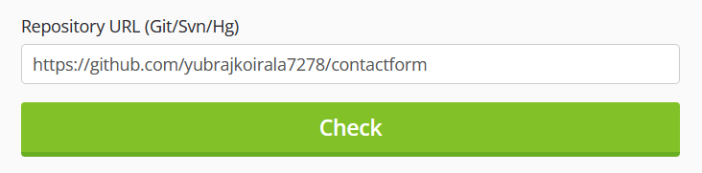

If there is an error then change the name in your composer.json file and

push the code again: (optional if error occurs)

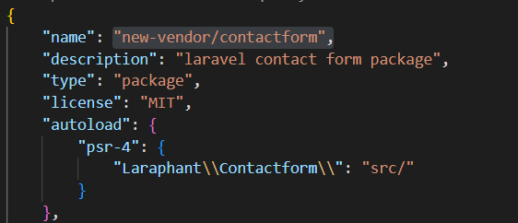

1. Go to your github package repo in github and click on **create a new release** like below:

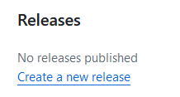



And then publish.

1. Congratulations! Your package has been published successfully!
2. Now, using your package in another project. The steps are given below:
3. In your new project install your package:

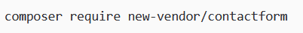

In .env file:

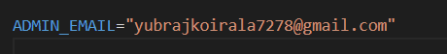

Write below command to publish your package:



Now migrate the contacts table that we have used in our package.

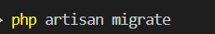

If you haven’t setup then setup below code:

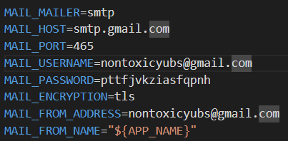

Now go to /contact url and use the contact us form.

# **Use MongoDB(NoSQL) in Laravel:**

<https://www.mongodb.com/resources/products/compatibilities/mongodb-laravel-integration>

1. composer require mongodb/laravel-mongodb
2. Inside database.php (inside connections array)

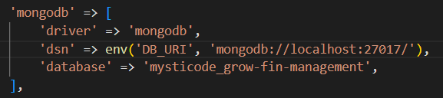

1. Inside app.php

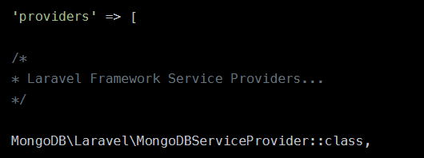

1. Make model and controller:

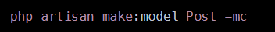

1. Inside Post Model:

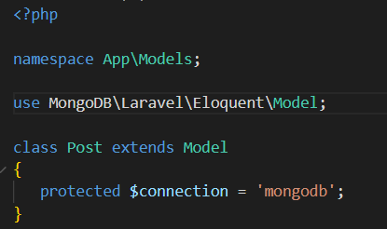

1. Inside Post Controller to add post:

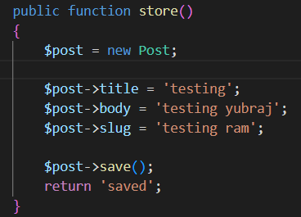

1. Inside web.php



1. php artisan migrate:fresh --database=mongodb

# **Unit Testing:**

Unit Testing is a software development practice that helps developers to ensure that individual units or components of their code are working as intended. In fact, most unit tests probably focus on a single method.

Inside phpunit.xml:

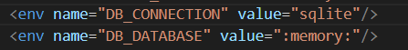

1. Make test:

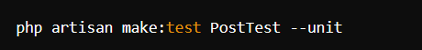

1. Inside PostTest

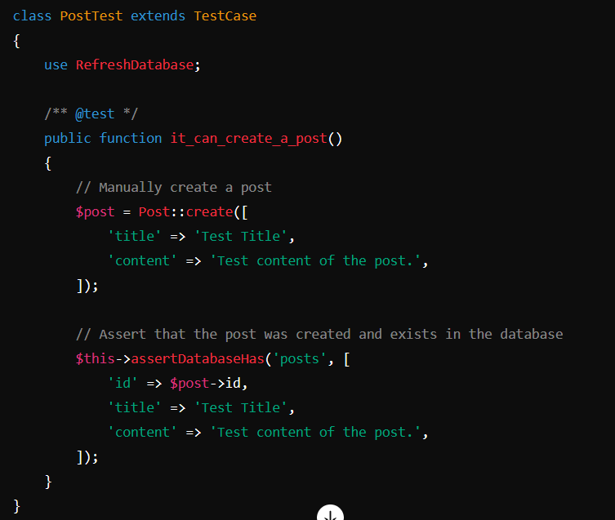

1. Run Test:



Or

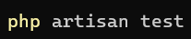

Or

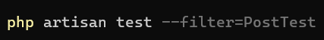

## **Check User Status (Online or Offline)**

1. In Users table:

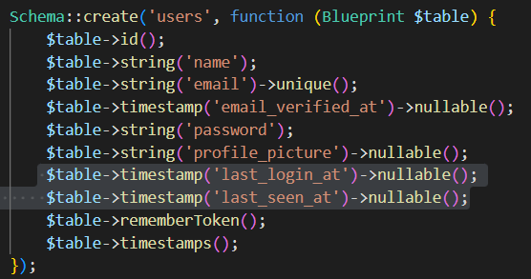

1. Inside EventServiceProvider.php:

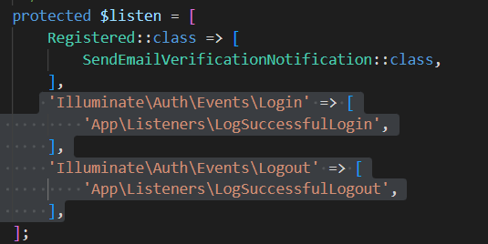

1. Create a Listener to check login user:

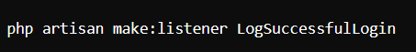

1. Inside app/Listeners/LogSuccessfulLogin.php:

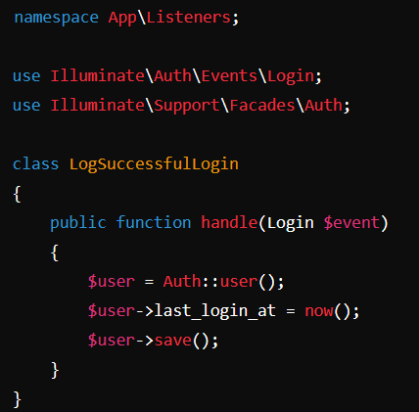

1. Create listener to check logout user:



1. Inside app/Listeners/LogSuccessfulLogout.php:

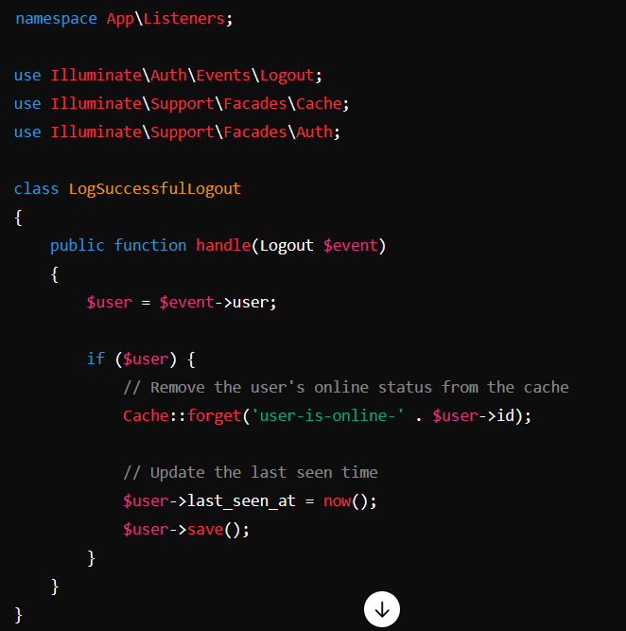

1. Inside app/User.php model:

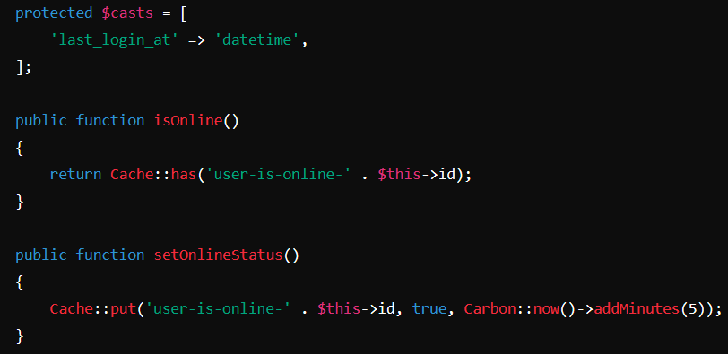

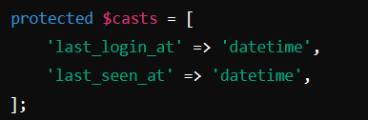

1. Create a middleware:

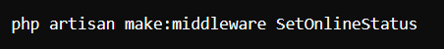

1. Inside app/Http/Middleware/SetOnlineStatus.php:

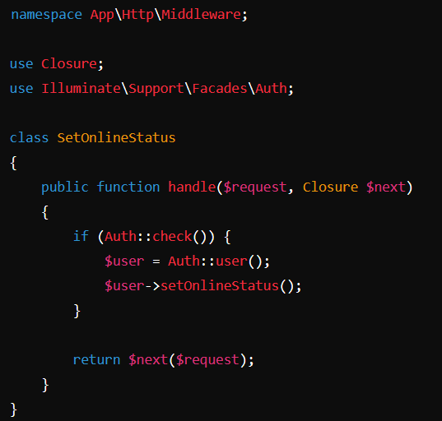

1. Inside app/Http/Kernel.php:

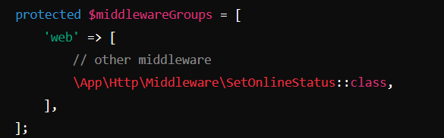

1. Inside your controller:

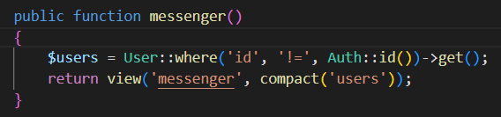

1. Inside your blade file:

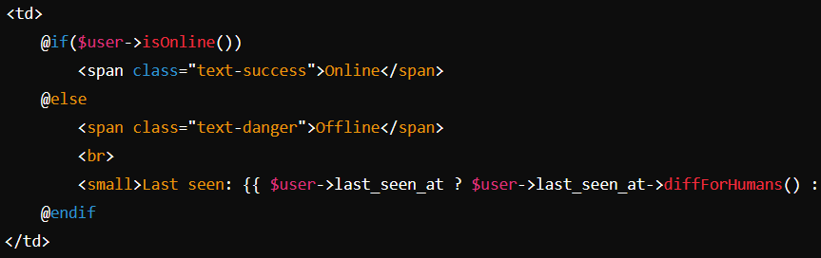

## **Filters with AJAX:**

* **Filter with Searching Keyword:**

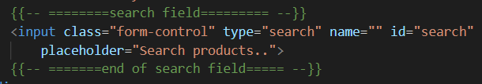

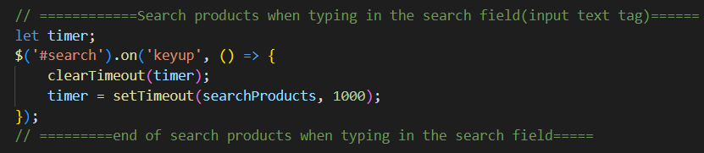

* **Filter with Select Field:**

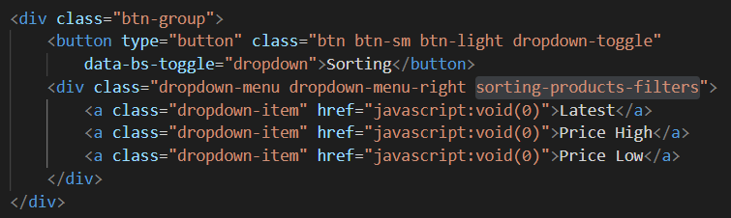

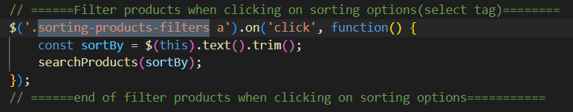

* **Filter with Checkbox:**

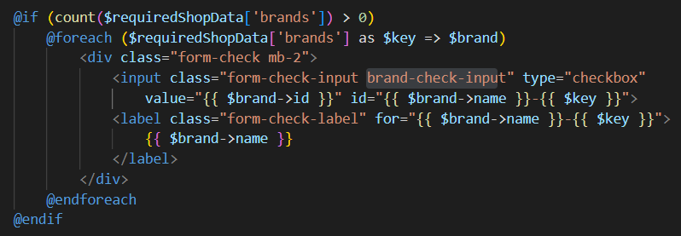

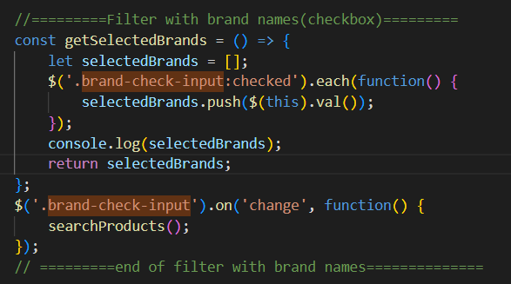

* **Filter with radio button:**

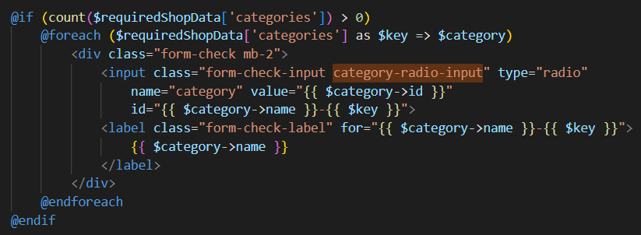

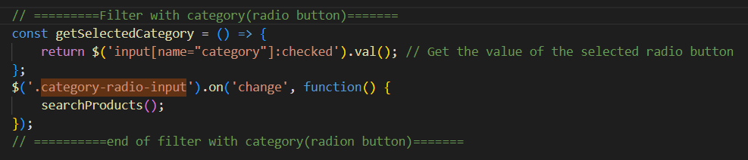

* **Filter with price range:**

{{-- price range slider range --}}

    <link rel="stylesheet" href="https://cdnjs.cloudflare.com/ajax/libs/noUiSlider/14.6.4/nouislider.min.css" />

    <script src="https://cdnjs.cloudflare.com/ajax/libs/noUiSlider/14.6.4/nouislider.min.js"></script>



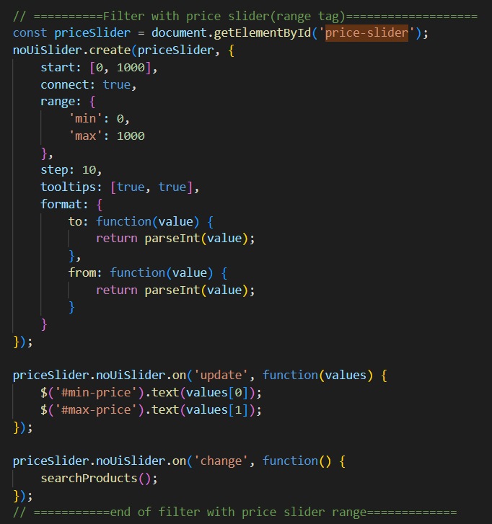

* Ajax Call for filter and sorting and display products:

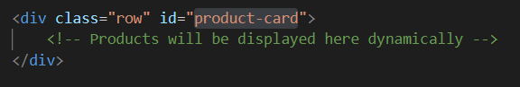

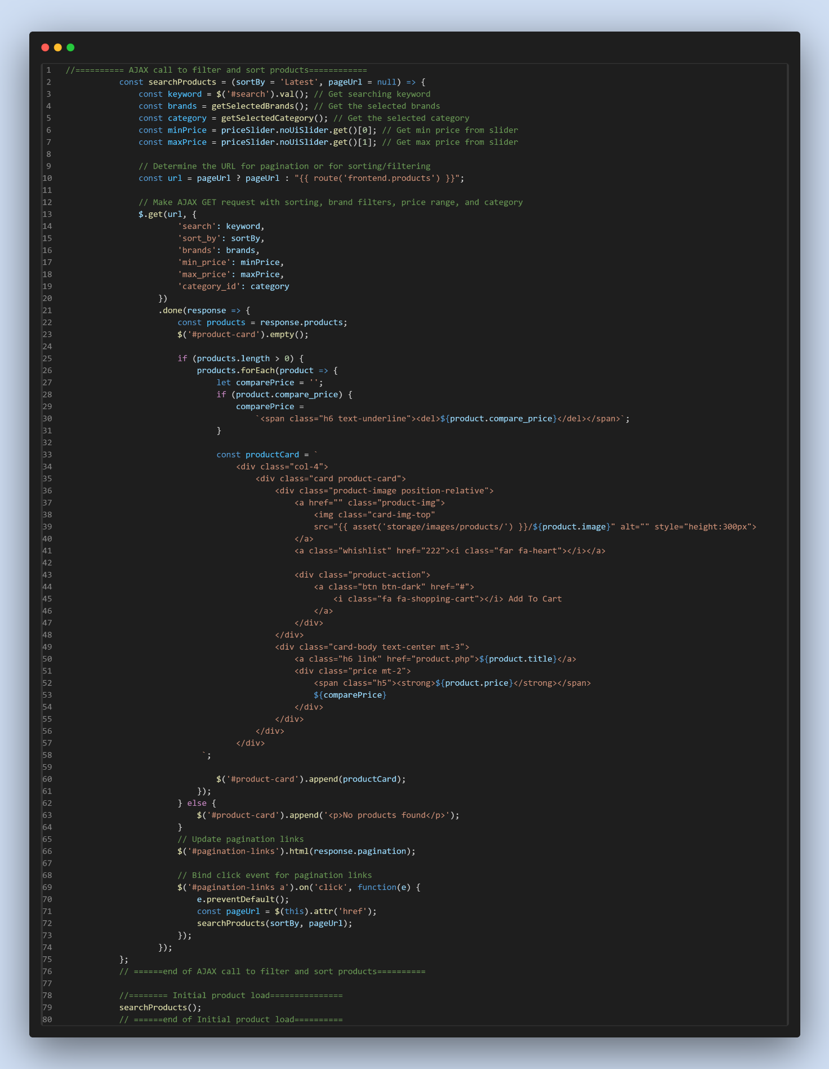

* **Inside Controller:**

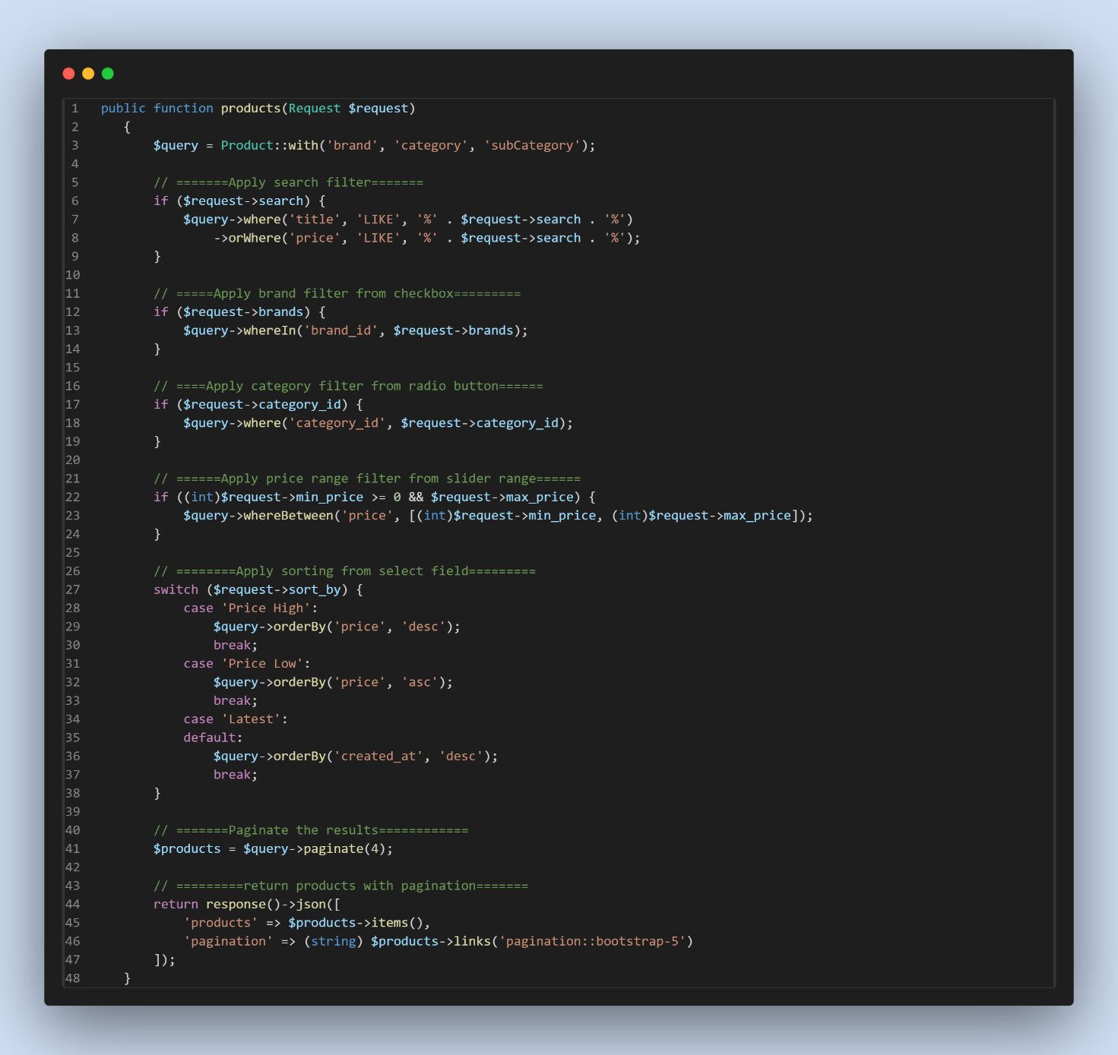

**In web.php**

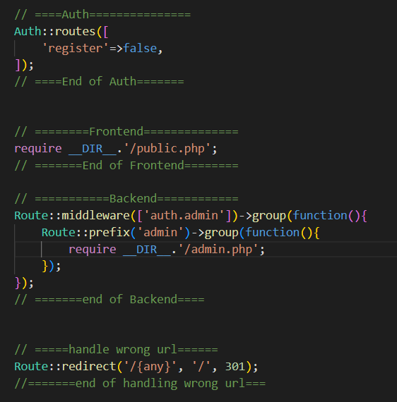

**Inside public.php**



**Inside admin.php**

